Monday, August 29, 2016

Monday, August 29, 2016

8:00 PM

**Objective**

* Obtain two environmental samples containing bacteriophage

**Procedure**

* I followed the Sample Collection Protocol to collect two samples on August 29, 2016.
* I found one sample outside the Honors College and Residences South Building. There is currently construction going on in and around the building, so I took a sample from the mud next to a location where landscaping is to be added within the next few days. It rained recently, so the sample is mostly from a puddle of standing water in the mud.
* I found the second sample in the westernmost sand volleyball courts of the recreational facilities on campus.

**Data**

*Table 1: Sample 1 & 2 Collection Data*

|  |  |  |
| --- | --- | --- |
| **Sample** | **Sample 1** | **Sample 2** |
| **Date** | 8/29/2016 | 8/29/2016 |
| **Time** | 7:36 pm | 7:46 pm |
| **Location (Google Earth Coordinates)** | 40.426183, -86.919638 (Figure 2) | 40.428173, -86.925473 (Figure 3) |
| **Depth (to nearest cm)** | 1 cm | 2 cm |
| **Approx. Moisture Content of Soil** | Nearly all water | Very dry, nearly no water |
| **Urban/Rural** | Urban/Suburban | Urban/Suburban |
| **Proximity to foot traffic/cement/major roads/ trees/ etc.** | Foot traffic < 0.5m, cement < 0.5m, roads < 30m, trees < 30m | Foot traffic = 0 cm, cement < 1m, trees < 30m, roads < 30m |
| **Sloped? Facing which direction?** | Not sloped | Not sloped |
| **Other (specify)** | Standing water, very muddy/murky, near construction site | Sand from volleyball court |

**Photographs of Samples and Locations**

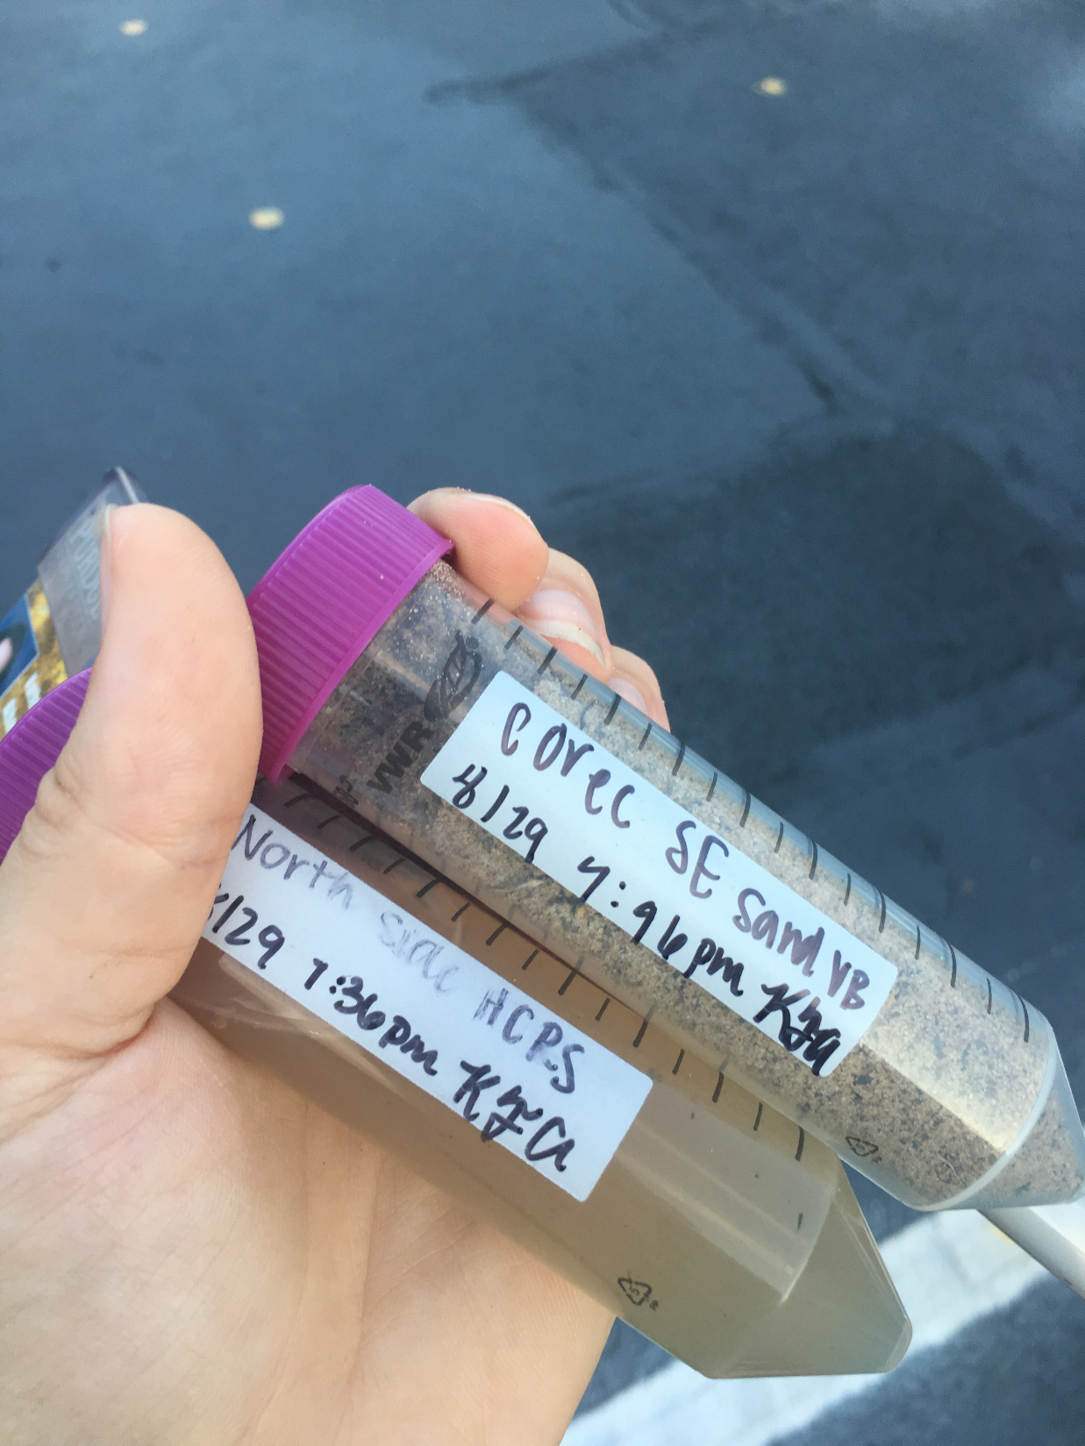

*Figure 1: Samples (Kathryn Atherton) in Collection Tubes*

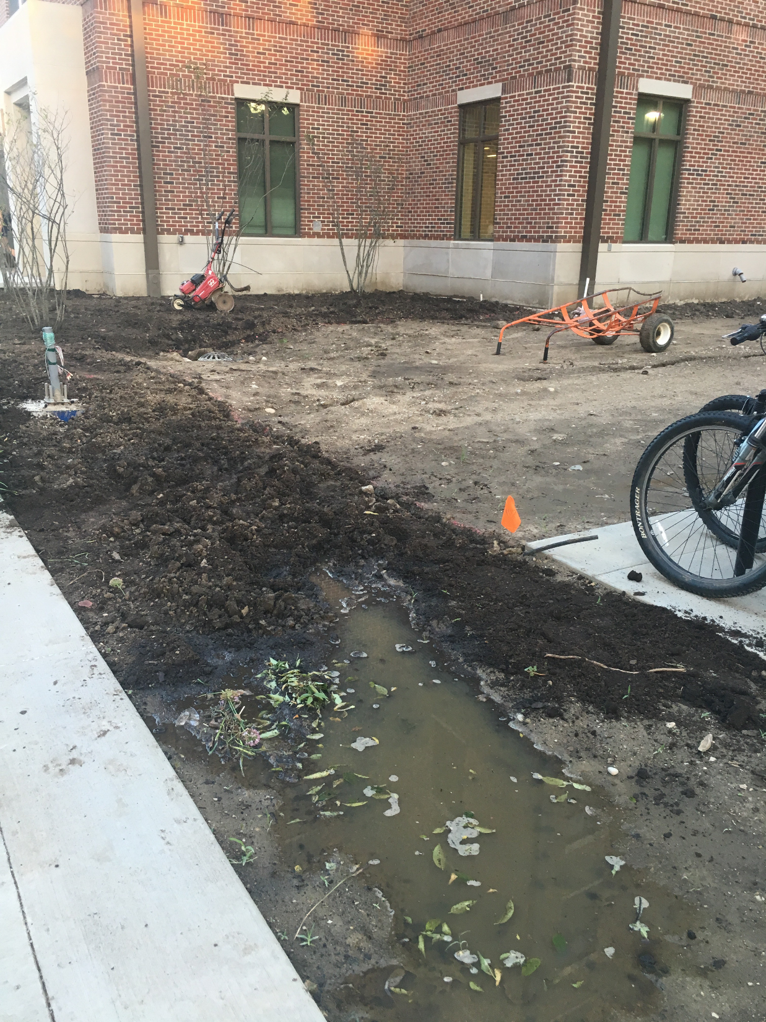

*Figure 2: Sample 1 (Kathryn Atherton) Collection Location*

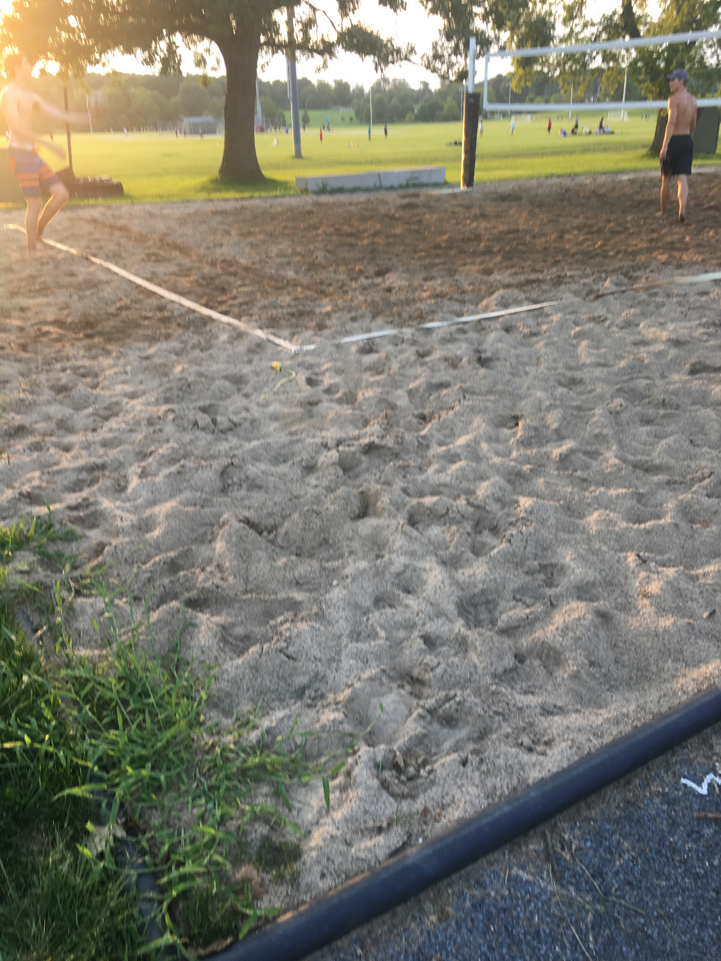

*Figure 3: Sample 2 (Kathryn Atherton) Collection Location*

**Future Actions**

* Sample 1 will be prepared, plated, and incubated on August 30, 2016 to see if phage have been collected.

Tuesday, August 30, 2016

Tuesday, August 30, 2016

11:30 AM

**Objective**

* Extract phage from my first environmental sample

**Procedure**

* I followed the Sample Preparation Procedure.
  + I walked into lab, washed my hands, and cleaned my work bench with the brown detergent and ethanol.
  + I prepared my work bench by getting all the supplies I needed: burner components, my team's tube rack, electric pipettor and 5ml tips, 15 ml conical tubes, 2-20 microL and 200-1000 micorL micropipettors with tips, a microcentrifuge tube, syringe, syringe filter, 2 host bacteria samples, 2 agar plates, a permanent marker, labeling tape, and my Sample 1
  + I assembled and lit the burner.
  + My teammate prepared a solid sample. As mine was liquid and skipped the step 3 in the protocol, I helped her with the third step.
  + Soo used my water sample as the example for the filtering and plating of the sample preparation protocol. I took notes on her technique as she showed the class how to prepare and plate the samples.
  + My teammate retrieved her solid sample from the shaking incubator. We helped each other prepare and plate her sample 1 as well as a negative control plate.
  + After waiting 10 minutes, we plated the samples.
  + We put away all supplies, cleaned up our work space, and washed our hands.

**Data**

Sample prepared: Sample 1 (8/30/2016)

* Time taken to settle after shake incubation: N/A -- liquid sample
* Incubation time: 48 hours
* Incubation temperature: 37 deg C

**Future Actions**

* Thursday, September 1, the Sample 1 plates will be inspected for plaques.
* If one or more is found, the plaque picking procedure will be performed.
* If not, the procedure performed today will be repeated with sample 2.

Thursday, September 1, 2016

Thursday, September 1, 2016

11:30 AM

**Objective**

* Determine if plaques have grown from collected phage.
* Extract phage from my second environmental sample

**Procedure**

* I followed the Sample Plaque Assay Continuation and Sample Preparation protocols
  + I entered lab, washed my hands, and cleaned up my workspace with the brown detergent and ethanol.
  + I grabbed the plates my partner and I had made last time.
  + My partner and I inspected the plates, noted our observations, and took photos of the plates (See Data Notes and Figure 4)
  + As no plaques were found, the Sample Preparation procedure was repeated with the my Sample 2.
  + My partner and I prepared our work bench by getting all the supplies needed: burner components, the tube rack, electric pipettor and 5ml tips, 15 ml conical tubes, 2-20 microL and 200-1000 micorL micropipettors with tips, a microcentrifuge tube, syringe, syringe filter, 2 host bacteria samples, 2 agar plates, a permanent marker, labeling tape, and our Sample 2s.
  + My partner assembled and lit the burner.
  + This time I prepared a solid sample and my partner prepared a liquid sample and skipped the step 3 in the protocol, she helped me with the third step.
  + I retrieved my solid sample from the shaking incubator after the allotted time. We helped each other prepare our Sample 2s to inoculate the bacteria host as well as a negative control (See Data Notes).
  + After waiting 10 minutes for the phage to infect the bacteria, we plated the samples.
  + We put away all supplies, cleaned up our work space, and washed our hands.

**Data**

Sample 1 Plaque Notes

* Air bubble holes, but no plaques

Control Plaque Notes (9/1/2016)

* No plaques

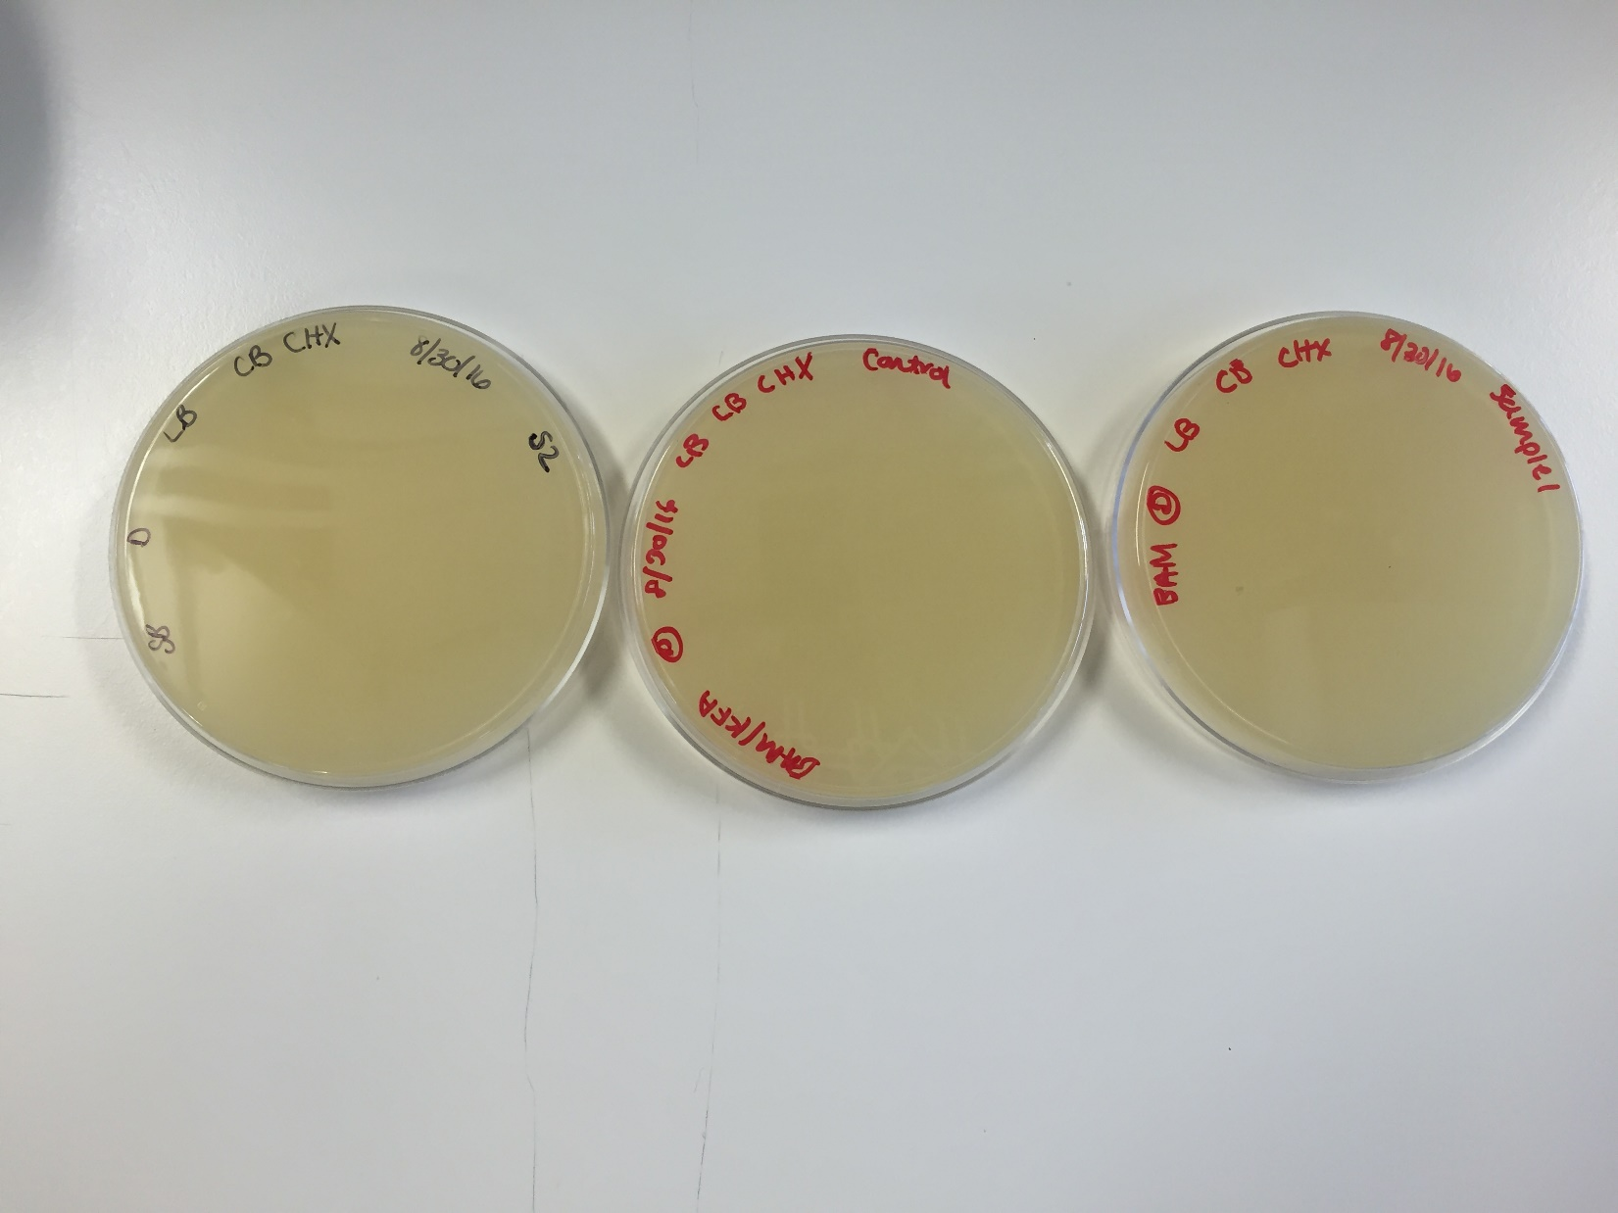

*Figure 4: Sample 1 (Kathryn), Control, and Sample 1 (Barbara) Plates*

-----

Sample prepared: Sample 2

* Time taken to settle after shake incubation: 2 min
* Incubation time: 48 hours
* Incubation temperature: 37 deg C

**Future Actions**

* The sample 2 plates will be incubated over the weekend and will be inspected on Tuesday, September 6, 2016.
* If one or more is found, the plaque picking procedure will be performed.
* If not, new samples will be collected and the procedure performed today will be repeated with those.

Tuesday, September 6, 2016

Tuesday, September 6, 2016

11:30 AM

**Objective**

* Determine if plaques have grown from collected phage.
* Obtain an environmental sample containing bacteriophage
* Extract phage from my third environmental sample

**Procedure**

* I followed the Sample Plaque Assay Continuation, Sample Collection, and Sample Preparation protocols
  + I entered lab, washed my hands, and cleaned up my workspace with the brown detergent and ethanol.
  + I grabbed the plates my partner and I had made last time.
  + My partner and I inspected the plates, noted our observations, and took photos of the plates (See Data Notes and Figure 5)
  + As no plaques were found, the Sample Collection procedure was repeated.
    - New samples were collected from outside the Discovery Learning Research Center (See Data Table 2 and Figure 6)
  + Sample Preparation procedure was repeated with these new samples.
  + My partner and I prepared our work bench by getting all the supplies needed: burner components, the tube rack, electric pipettor and 5ml tips, 15 ml conical tubes, 2-20 microL and 200-1000 micorL micropipettors with tips, a microcentrifuge tube, syringe, syringe filter, 2 host bacteria samples, 2 agar plates, a permanent marker, labeling tape, and our Sample 2s.
  + My partner assembled and lit the burner.
  + This time we both prepared a solid sample, so we helped each other with step 3.
  + We retrieved our solid samples from the shaking incubator after the allotted time. We helped each other prepare our Sample 3s to inoculate the bacteria host as well as a negative control (See Data Notes).
  + After waiting 10 minutes for the phage to infect the bacteria, we plated the samples.
  + We put away all supplies, cleaned up our work space, and washed our hands.

**Data**

Sample 2 Plaque Notes (9/6/2016)

* Air bubble holes, but no plaques

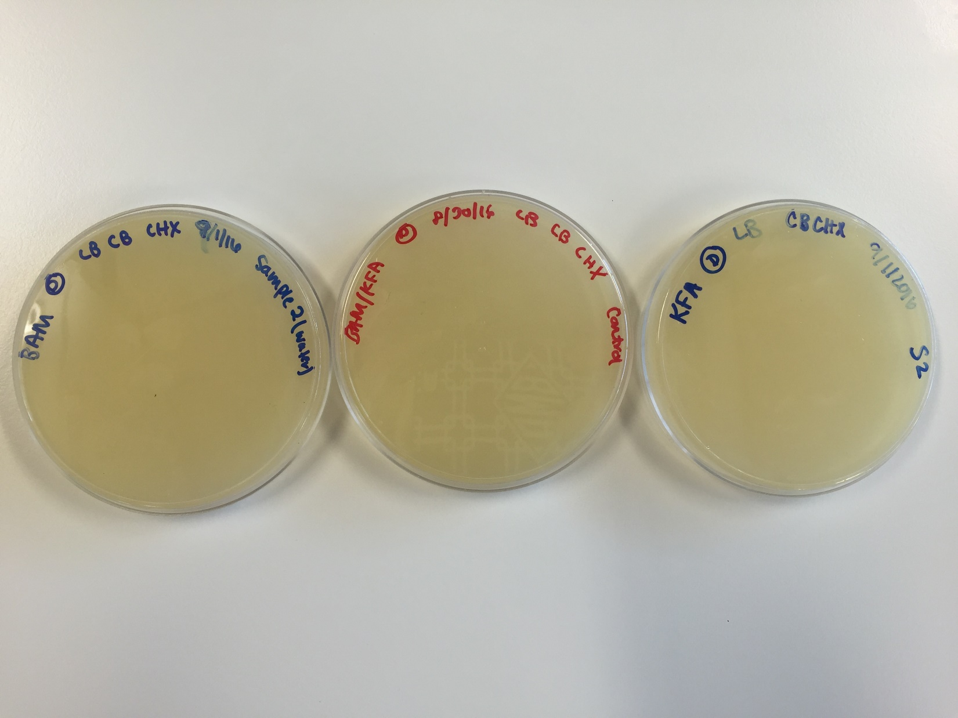

*Figure 5: Sample 2 (Barbara), Control, and Sample 2 (Kathryn) Plates*

-----

*Table 2: Sample 3 Collection Data*

|  |  |
| --- | --- |
| **Sample** | **Sample 3** |
| **Date** | 9/6/2016 |
| **Time** | 11:35 am |
| **Location (Google Earth Coordinates)** | 40.421028, -86.922249 |
| **Depth (to nearest cm)** | 2 cm |
| **Approx. Moisture Content of Soil** | Dry with little moisture |
| **Urban/Rural** | Urban/Suburban |
| **Proximity to foot traffic/cement/major roads/ trees/ etc.** | Foot traffic < 5 cm,  Cement < 5 cm,  Roads < 3 m, trees < 10 m |
| **Sloped? Facing which direction?** | Not sloped |
| **Other (specify)** | Layer of soil just below mulch in plant bed outside Purdue DLRC |

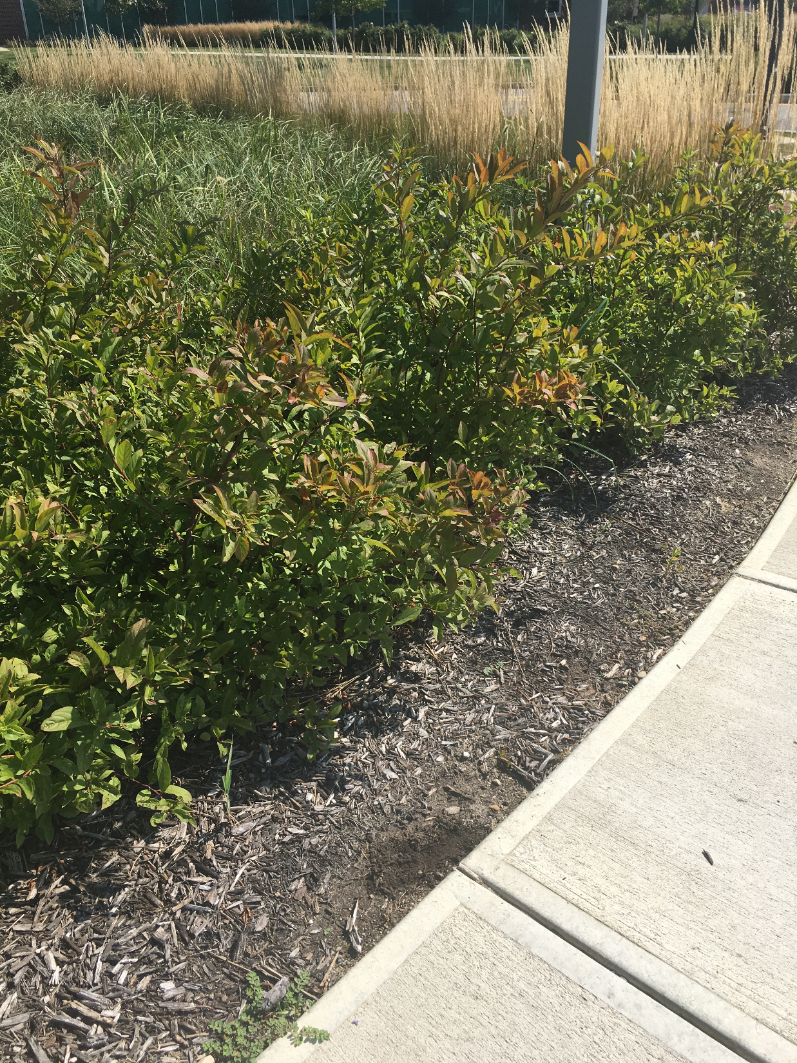

*Figure 6: Sample 3 (Kathryn Atherton) Collection Location*

------

Sample prepared: Sample 3 (9/6/2016)

* Time taken to settle after shake incubation: 5 min
* Incubation time: 48 hours
* Incubation temperature: 37 deg C

**Future Actions**

* The sample 3 plates will be incubated inspected on Thursday, September 8, 2016.
* If one or more is found, the plaque picking procedure will be performed.
* If not, new samples will be collected and the procedure performed today will be repeated with those.

Thursday, September 8, 2016

Thursday, September 8, 2016

11:30 AM

**Objective**

* Determine if plaques have grown from collected phage.
* Isolate and test phage to determine if identified plaques contained phage
* To prepare liquid phage samples of decreasing concentrations
* Prepare samples for plating and incubation

**Procedure**

* I followed the Sample Plaque Assay Continuation, Picking a Plaque, Serial Dilution, and Plating a Sample protocols
  + I entered lab, washed my hands, and cleaned up my workspace with the brown detergent and ethanol.
  + I grabbed the plates my partner and I had made last time.
  + My partner and I inspected the plates, noted our observations, and took photos of the plates (See Data Notes and Figures 7 & 8)
    - We discovered that one plate had possible plaques, while one just had contamination.
  + We circled 5 possible plaques on Barbara's Sample 3 and labeled them A-E (See Figure 9). We then recorded observations about the plaques (See Table 3)
  + We decided to pick plaque A and perform a serial dilution according to the protocol.
  + We then plated serial dilutions 10^-1 through 10^-8 and a negative control for plaque A.
  + We put our supplies away, cleaned our work bench with the brown detergent and ethanol, and washed our hands.

**Data**

Sample 3 Plaque Notes (9/8/2016)

* 14 possible plaques
* All cloudy, contamination, not phage

Sample 3 (Barbara) Plaque Notes (9/8/2016)

* One very dense area with many small, slightly hazy plaques surrounding it.

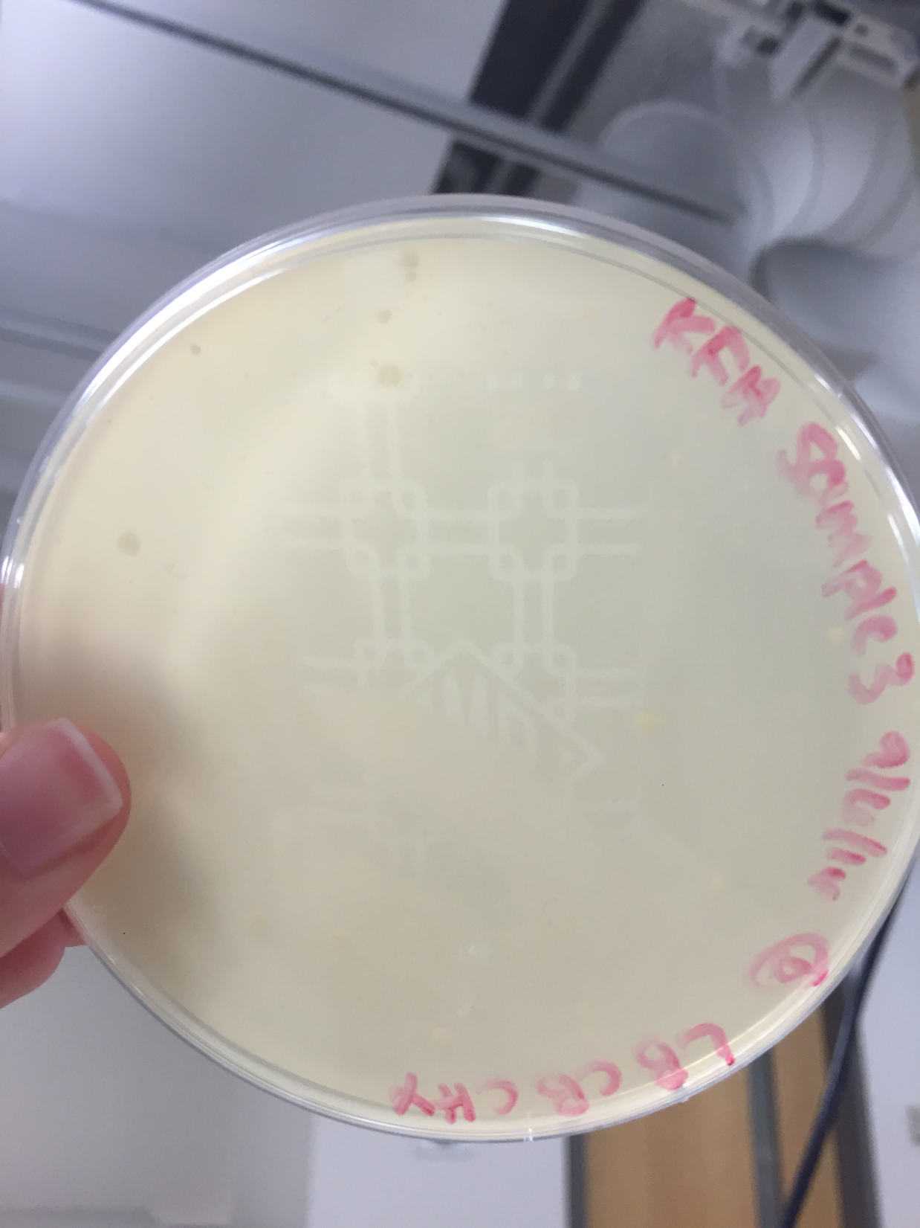

*Figure 7: Sample 3 (Kathryn) Plate*

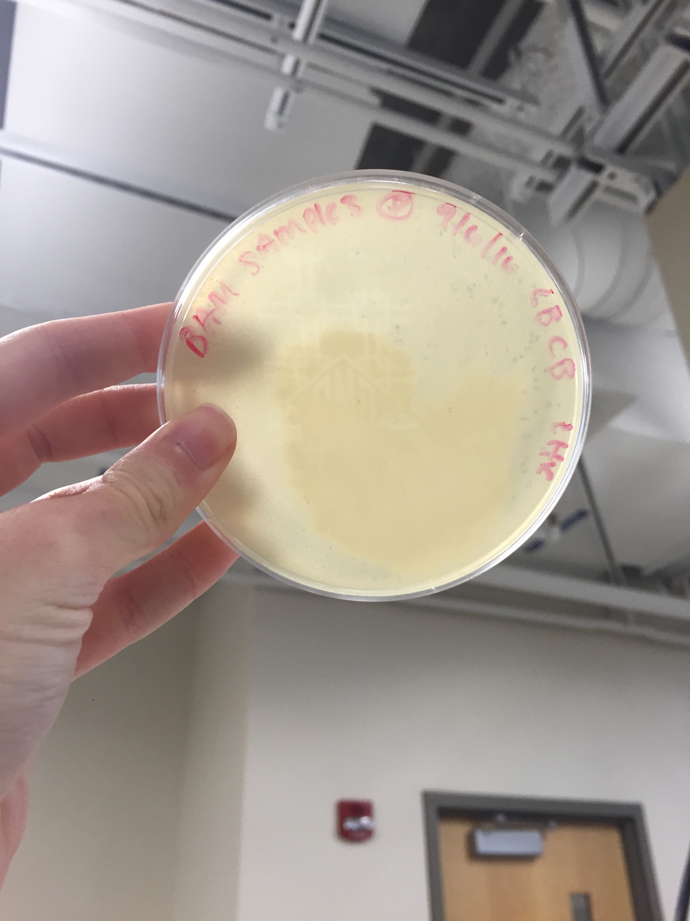

*Figure 8: Sample 3 (Barbara) Plate*

*-----*

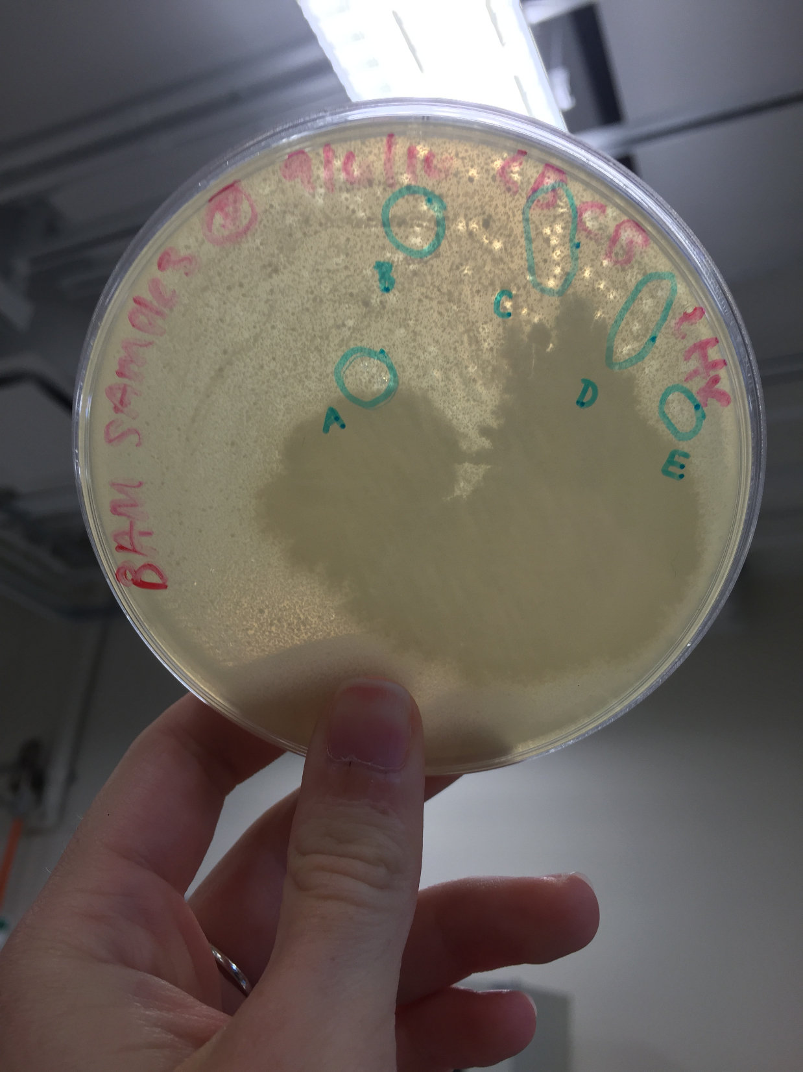

*Figure 9: Labeled Plaques*

*Table 3: Sample Plaque Data*

|  |  |  |  |  |
| --- | --- | --- | --- | --- |
| Plaques Picked | Description | Identifier | Date Picked | Plate Clearings? |
| Sample 3 (Barbara) | Small, clear, with smaller dots inside | A | 9/8/2016 | N/A |
| Sample 3 (Barbara) | Largest of those circled, clear, with smaller dots inside | B | N/A | N/A |
| Sample 3 (Barbara) | Small, very round, in a cluster of 6 plaques, clear with small dots inside | C | N/A | N/A |
| Sample 3 (Barbara) | Small, very round, in a cluster of 4 plaques, clear with small dots inside | D | N/A | N/A |
| Sample 3 (Barbara) | Cluster of 3 small round plaques, clear with small dots inside | E | N/A | N/A |

**Future Actions**

* The serial dilutions of Plaque A will be checked for clearings on Tuesday, September 13, 2016.
* If there are clearings, we will flood our best plate.
* If not, we will repeat today's procedure with a different plaque.

Tuesday, September 13, 2016

Tuesday, September 13, 2016

11:30 AM

**Objective**

* Determine if plaques have grown from the picked plaque
* Isolate and test phage to determine if the second identified plaque contained phage
* To prepare liquid phage samples of decreasing concentrations
* Prepare samples for plating and incubation

**Procedure**

* I followed the Sample Plaque Assay Continuation, Picking a Plaque, Serial Dilution, and Plating a Sample protocols
  + I entered lab, washed my hands, and cleaned up my workspace with the brown detergent and ethanol.
  + I grabbed the serial dilution plates my partner and I had made last time.
  + My partner and I inspected the plates, noted our observations, and took photos of the plates (See Tables 2 (copied and pasted from September 8 below) & 3 and Figures 10-18)
    - As there was not a clear pattern to the infection going down the serial dilution, a new plaque from the plate from Tuesday, September 6, 2016 was picked and a new serial dilution was created.
  + We decided to pick plaque B and perform a serial dilution according to the protocol.
  + We then plated serial dilutions 10^-1 through 10^-8 and a negative control for plaque B.
  + We put our supplies away, cleaned our work bench with the brown detergent and ethanol, and washed our hands.

**Data**

*Table 3: Sample Plaque Data (Updated)*

|  |  |  |  |  |
| --- | --- | --- | --- | --- |
| Plaques Picked | Description | Identifier | Date Picked | Plate Clearings? |
| Sample 3 (Barbara) | Small, clear, with smaller dots inside | A | 9/8/2016 | Yes, but not a logical pattern of infection (i.e. as the concentration lowered, the number of plaques increased, then decreased again) |
| Sample 3 (Barbara) | Largest of those circled, clear, with smaller dots inside | B | 9/13/2016 | N/A |
| Sample 3 (Barbara) | Small, very round, in a cluster of 6 plaques, clear with small dots inside | C | N/A | N/A |
| Sample 3 (Barbara) | Small, very round, in a cluster of 4 plaques, clear with small dots inside | D | N/A | N/A |
| Sample 3 (Barbara) | Cluster of 3 small round plaques, clear with small dots inside | E | N/A | N/A |

*Table 4: Serial Dilution Plaque Data*

|  |  |  |
| --- | --- | --- |
| Plate | Description | Best Plate? |
| Neg Control | 10-12 small contamination spots | N/A |
| 10^-1 | 15 round cloudy spots about 1mm across | No |
| 10^-2 | 5 round cloudy spots about 1mm across with a large, dense cloud in the agar | No |
| 10^-3 | 10 round cloudy spots about 1mm across with a 1.5 inch diameter cloud in the agar | No |
| 10^-4 | 20 round cloudy spots about 1mm across | No |
| 10^-5 | Many round clear spots with cloudy edges about 1mm across, more clear spots than agar | Yes |
| 10^-6 | Many round clear spots with cloudy edges about 1mm across | No |
| 10^-7 | 30 round cloudy spots about 1mm across | No |
| 10^-8 | 2 round cloudy spots about 1mm across, large dense cloud in agar nearly covers plate | No |

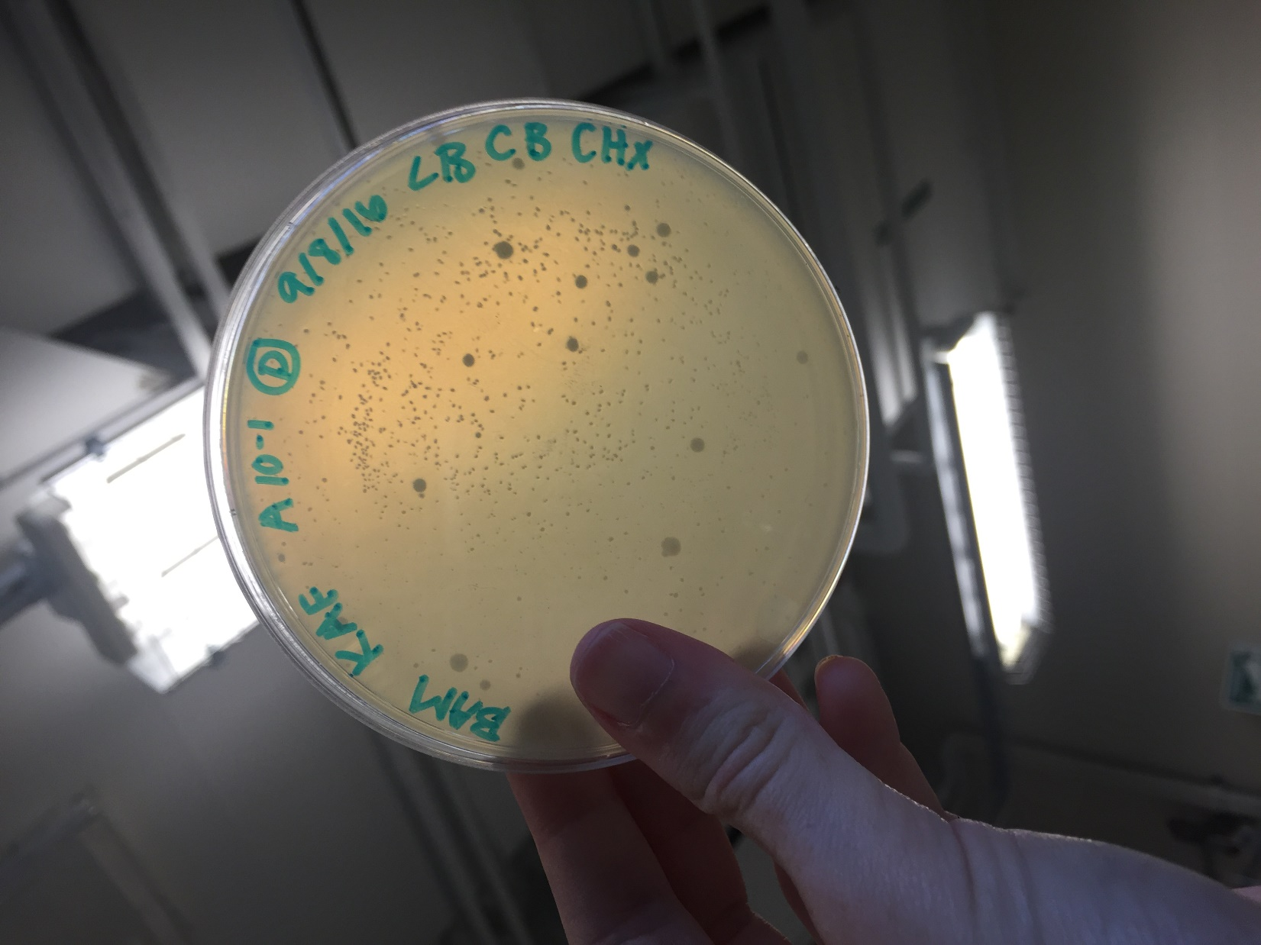

*Figure 10: Serial Dilution A 10^-1*

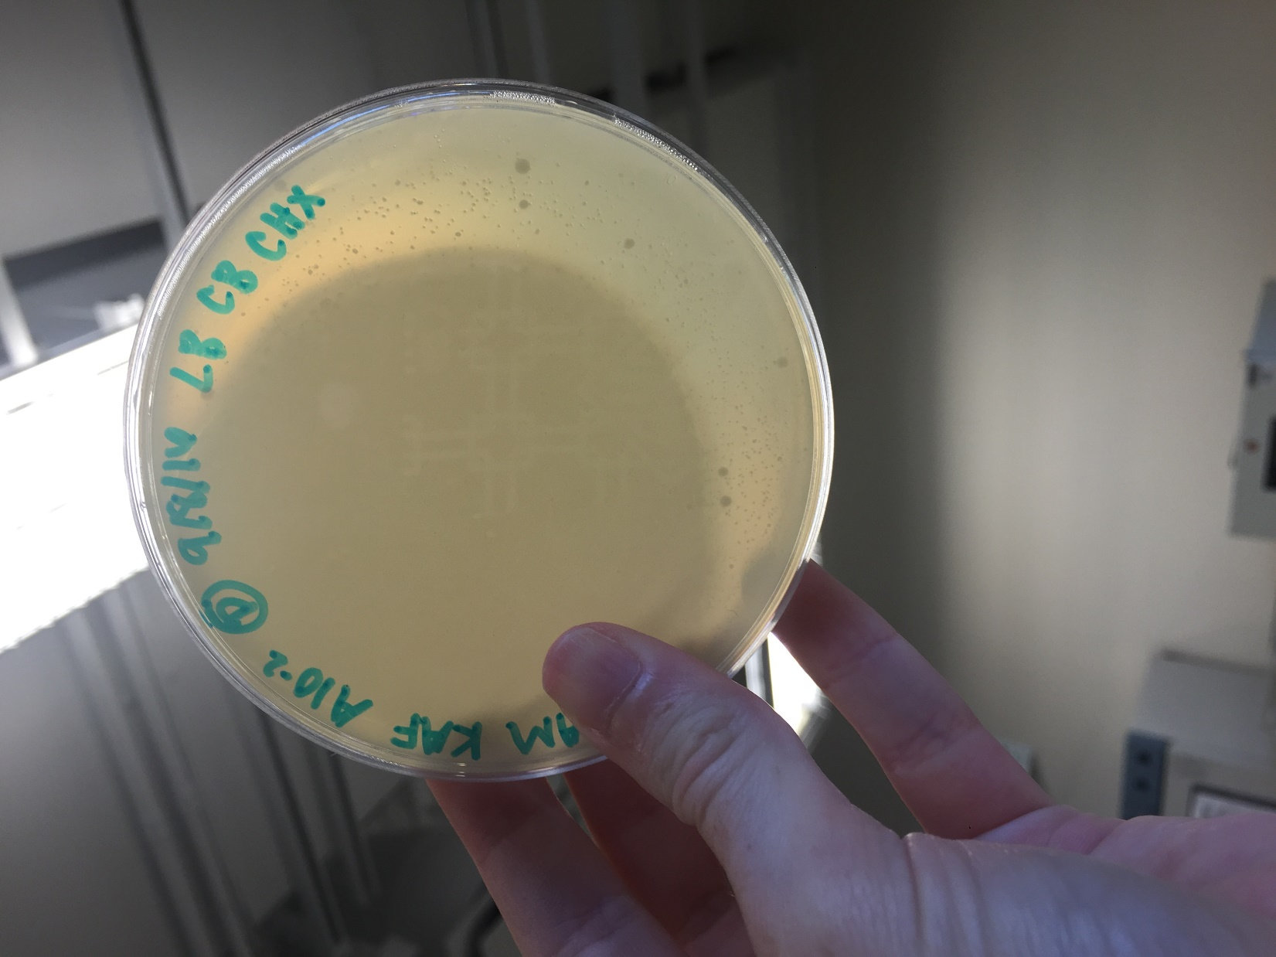

*Figure 11: Serial Dilution A 10^-2*

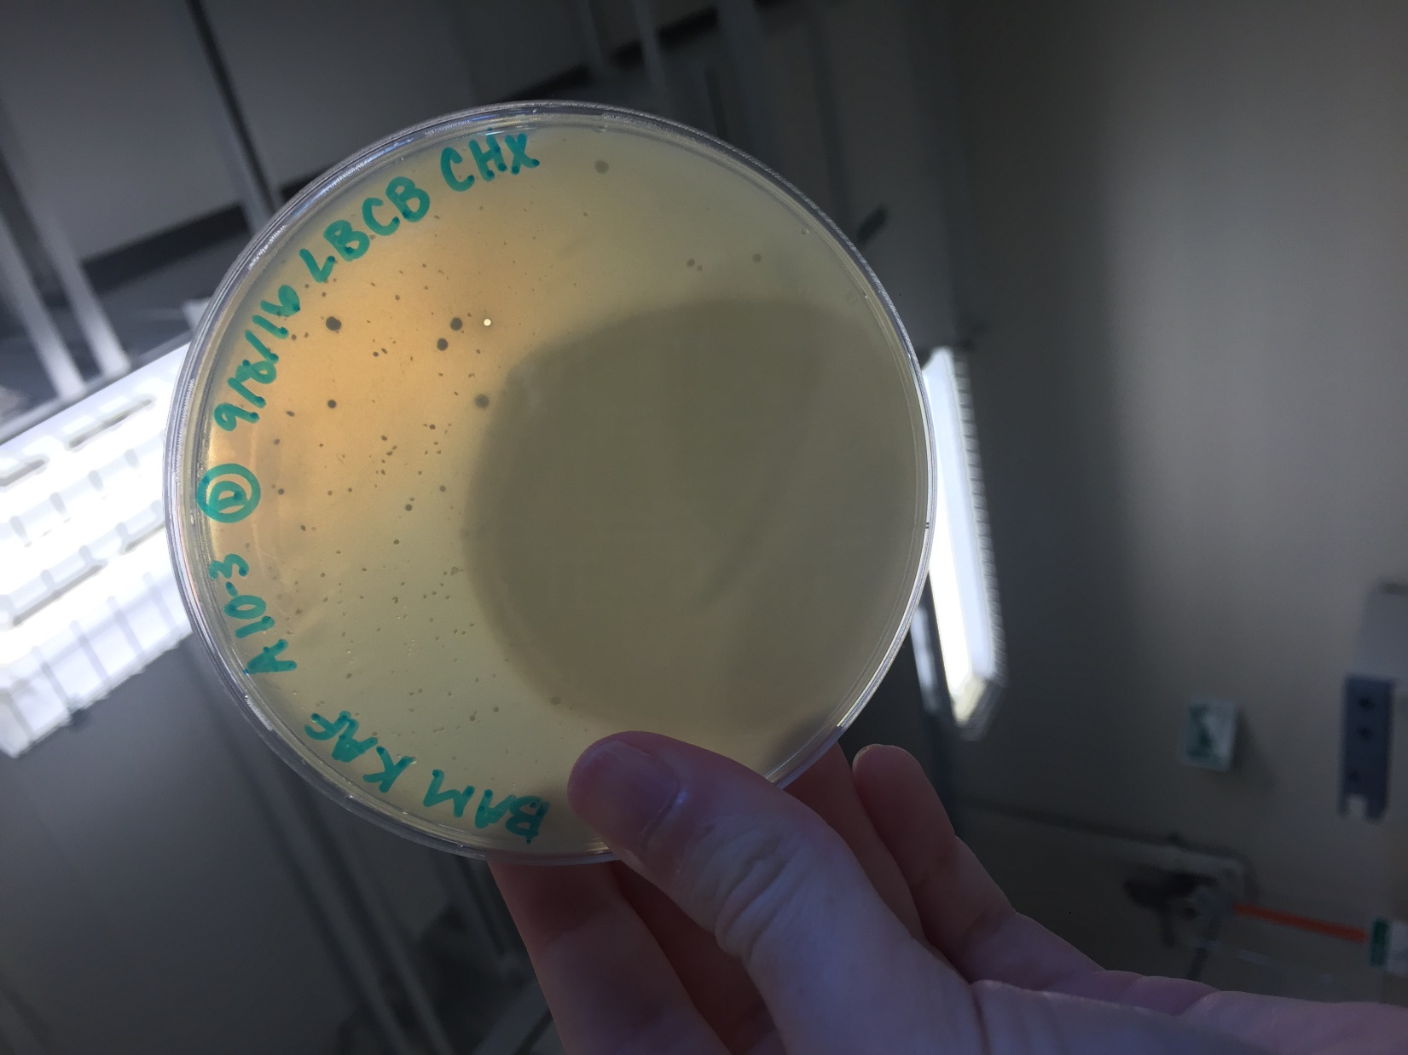

*Figure 12: Serial Dilution A 10^-3*

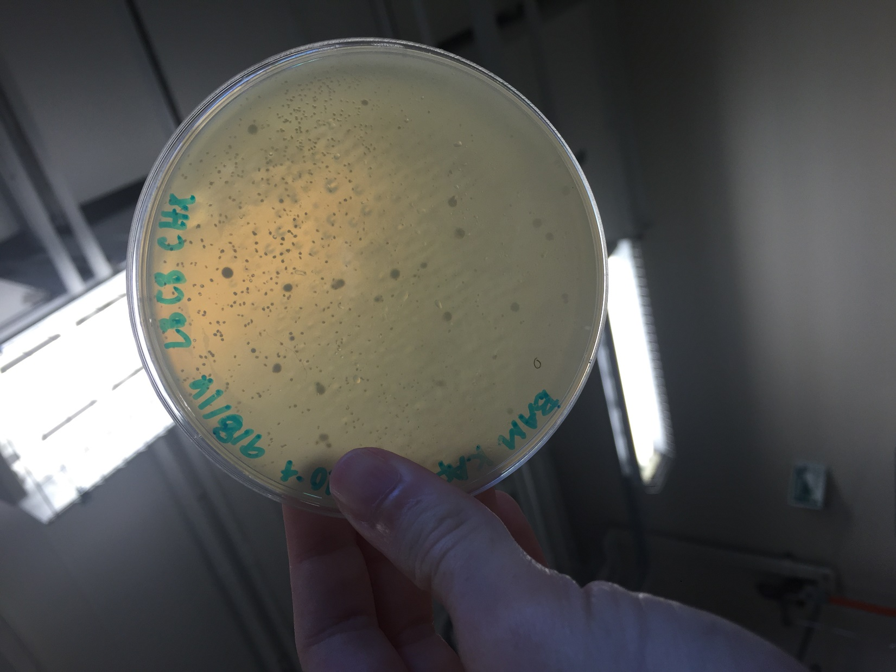

*Figure 13: Serial Dilution A 10^-4*

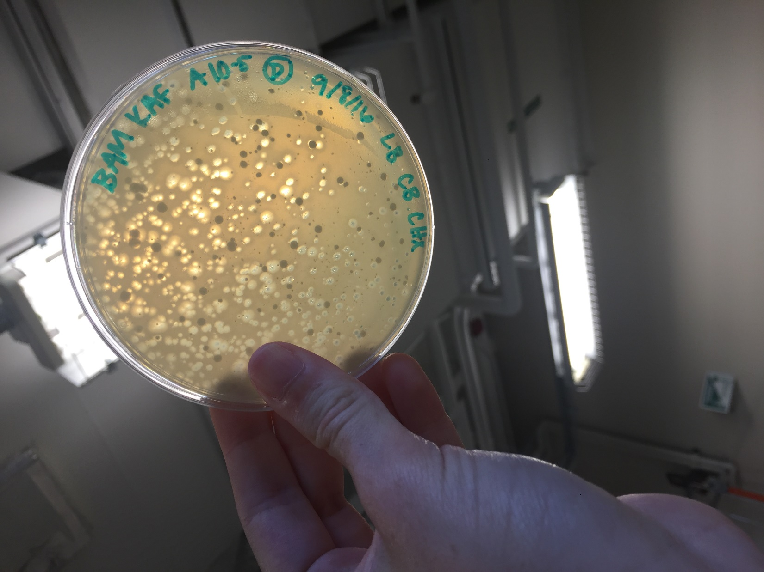

*Figure 14: Serial Dilution A 10^-5*

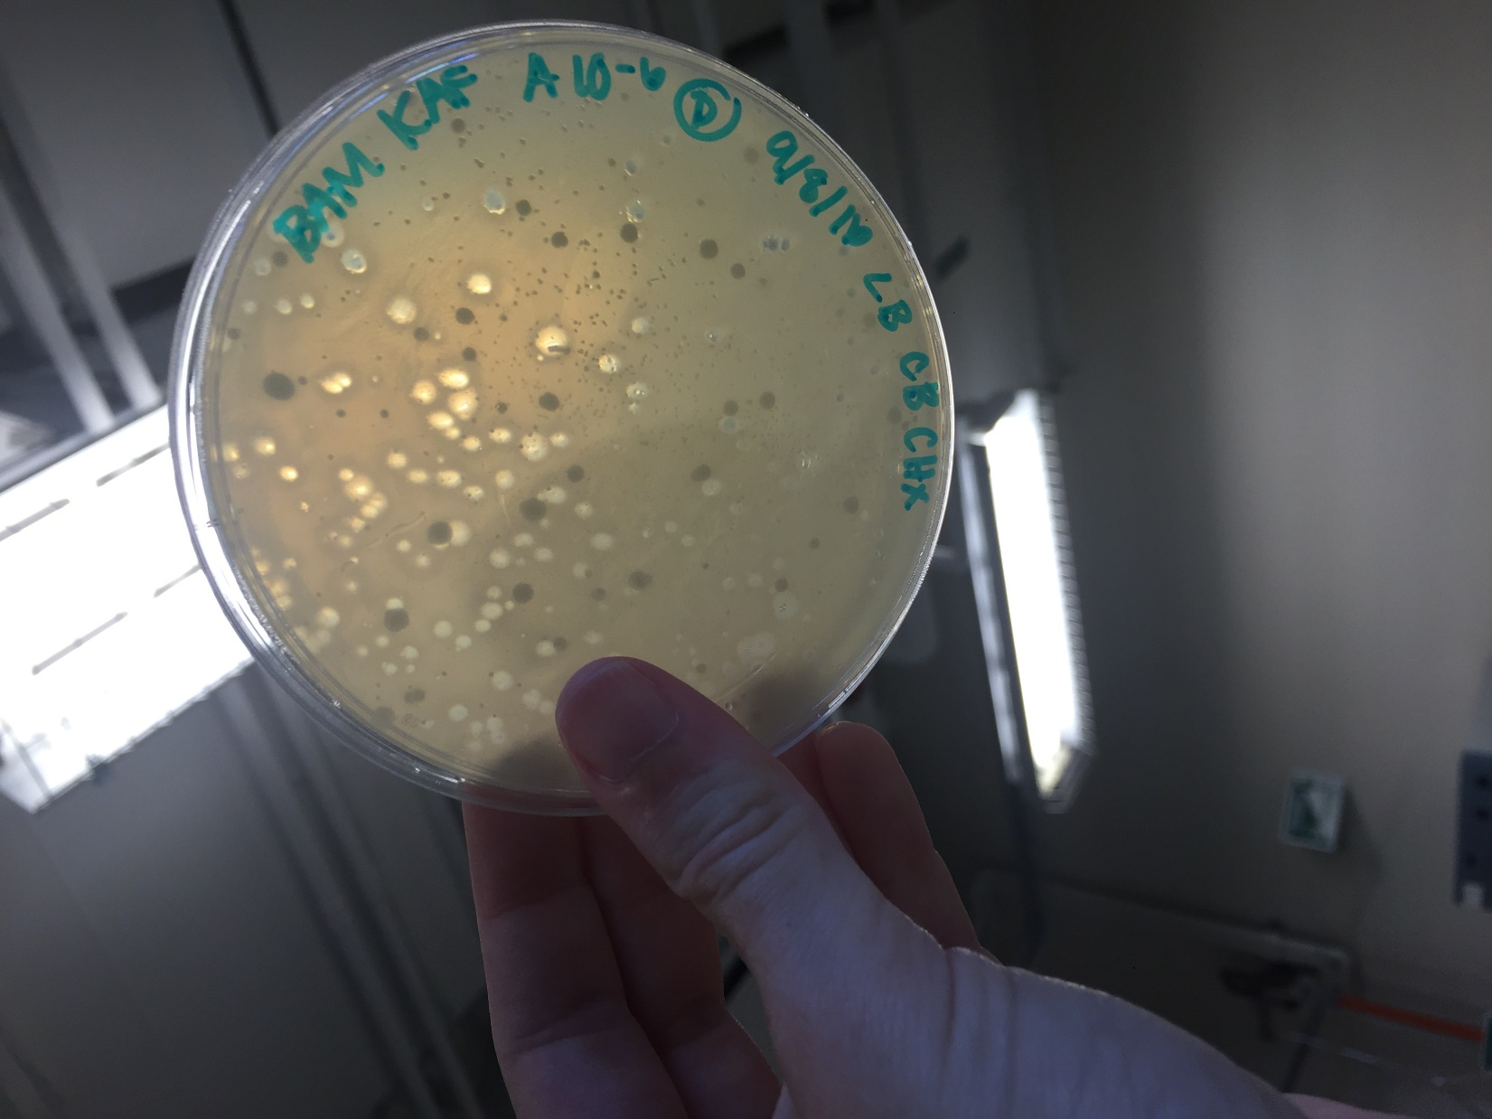

*Figure 15: Serial Dilution A 10^-6*

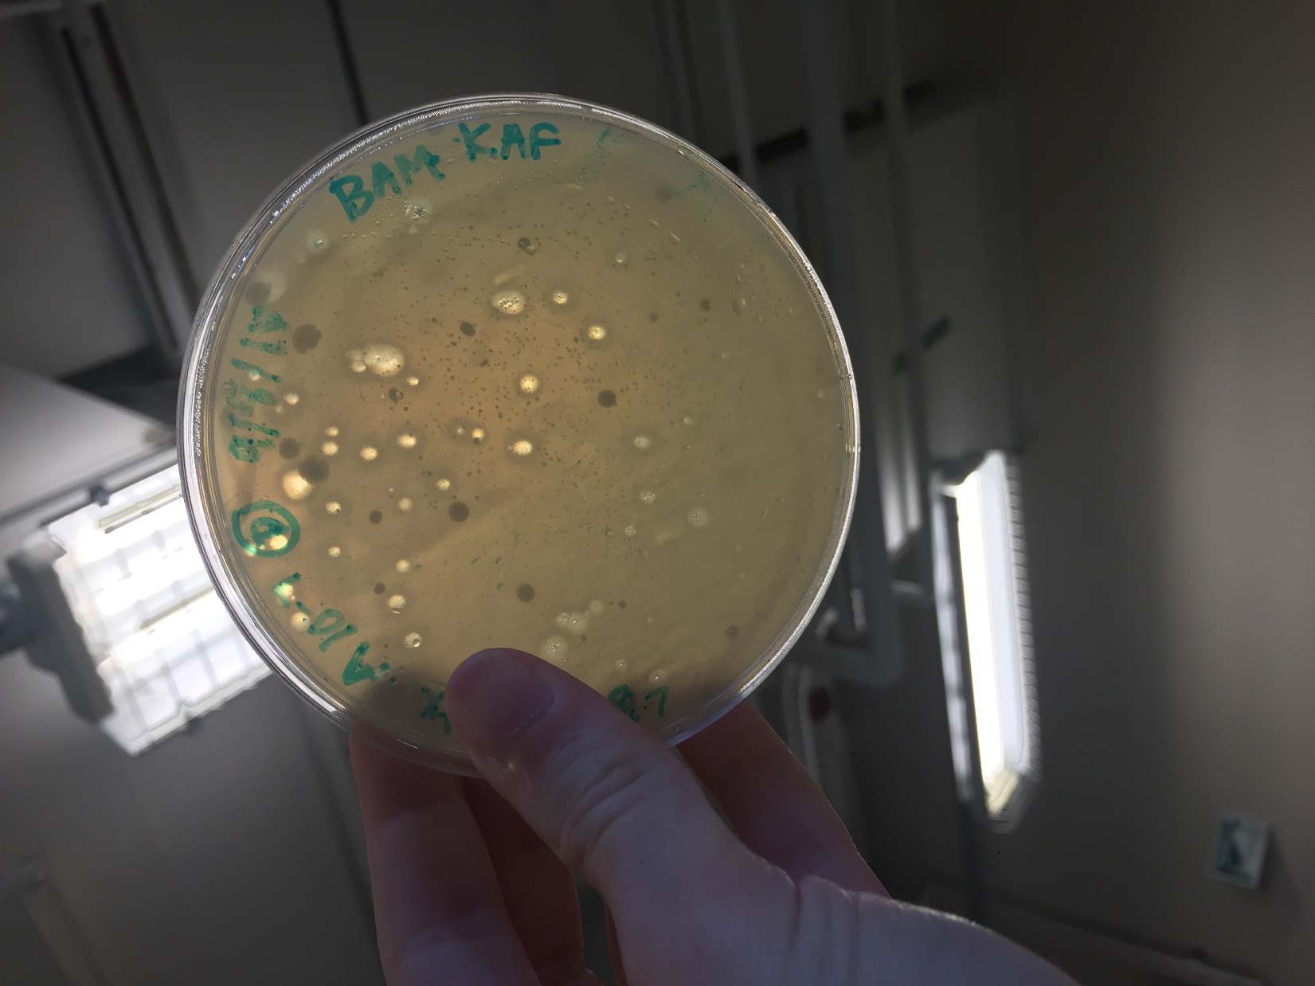

*Figure 16: Serial Dilution A 10^-7*

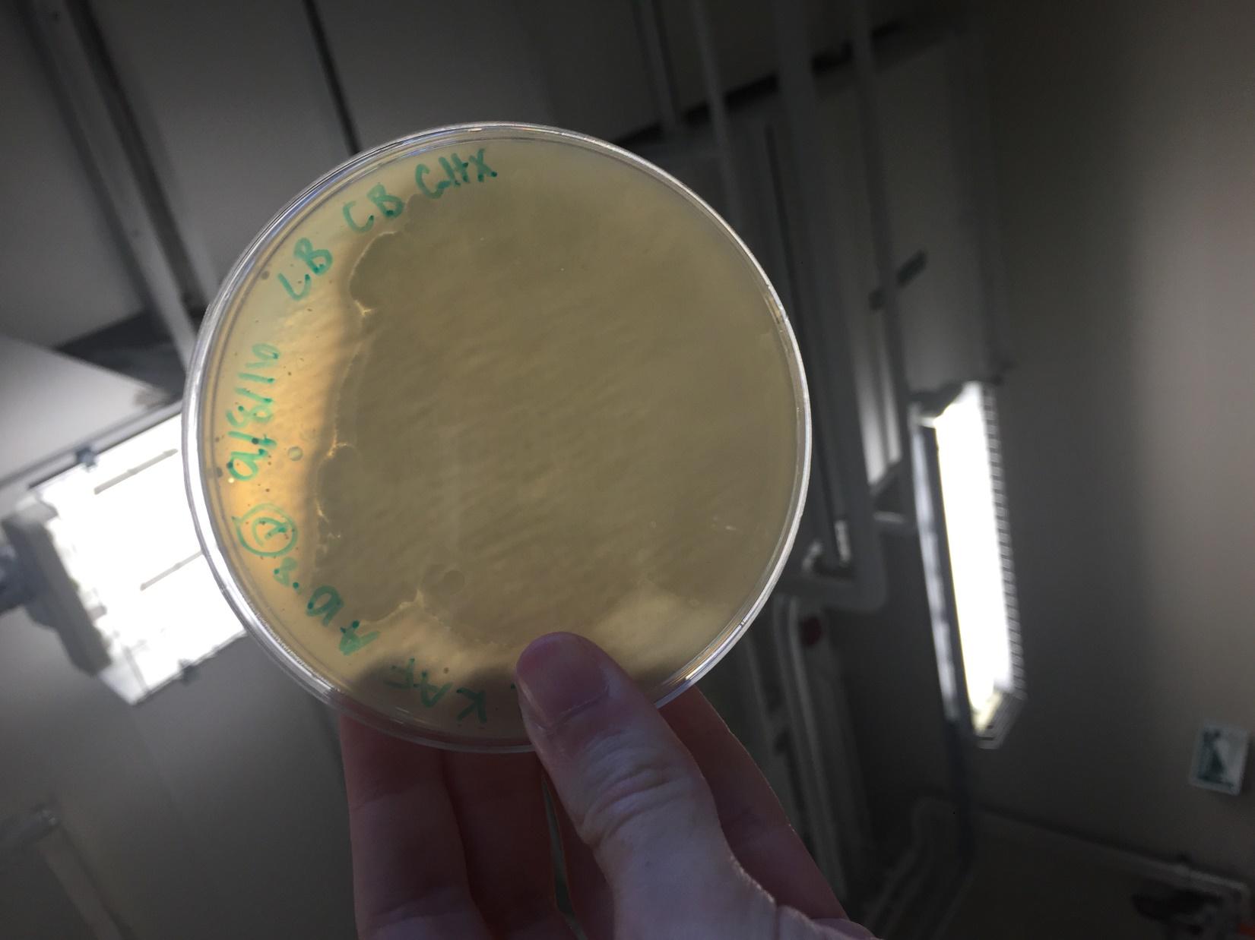

*Figure 17: Serial Dilution A 10^-8*

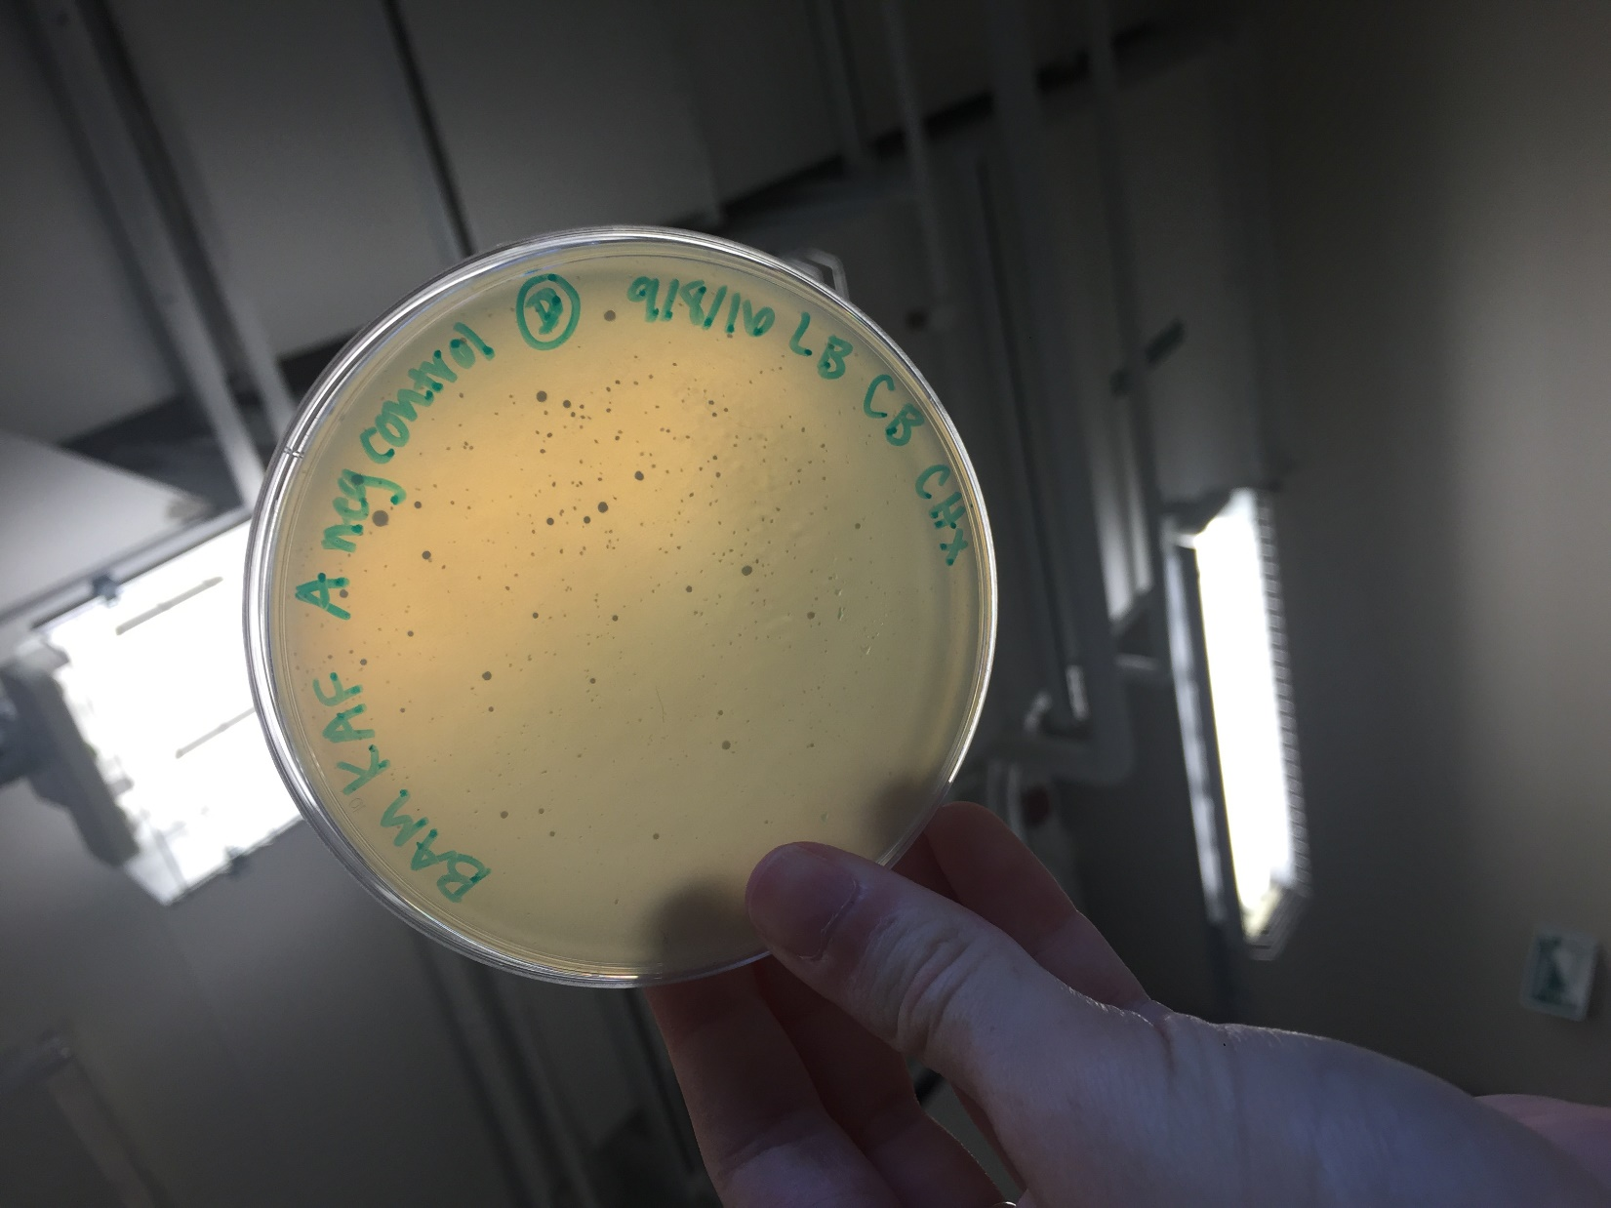

*Figure 18: Serial Dilution A Negative Control*

**Future Actions**

* The serial dilutions of Plaque B will be checked for clearings on Thursday, September 15, 2016.
* If there are clearings, we will flood our best plate.
* If not, we will repeat today's procedure with a different plaque.

Thursday, September 15, 2016

Tuesday, October 18, 2016

1:45 PM

**Objective**

* Determine if plaques have grown from the picked plaque
* Generate a highly concentrated liquid phage sample

**Procedure**

* I followed the Sample Plaque Assay Continuation and Flooding protocols
  + I entered lab, washed my hands, and cleaned up my workspace with the brown detergent and ethanol.
  + I grabbed the serial dilution plates my partner and I had made last time.
  + My partner and I inspected the plates, noted our observations, and took photos of the plates (See Tables 2 (copied and pasted from September 13 below) & 4 and Figures 19-27)
    - As there was a clear pattern to the infection going down the serial dilution, the 10^-2 dilution plate will be flooded and the 10^-3 plate will be wrapped and saved for future usage, in case the 10^-2 plate does not produce desirable results.
  + We added 8ml of phage buffer to the 10^-2 serial dilution plate, and wrapped it and the 10^-3 plate to save.
  + We scheduled a time to meet with Stephen on September 16, 2016 to collect the lysate.
  + We put away all of our supplies, cleaned our work bench, and washed our hands.

**Data**

*Table 3: Sample Plaque Data (Updated)*

|  |  |  |  |  |
| --- | --- | --- | --- | --- |
| Plaques Picked | Description | Identifier | Date Picked | Plate Clearings? |
| Sample 3 (Barbara) | Small, clear, with smaller dots inside | A | 9/8/2016 | Yes, but not a logical pattern of infection (i.e. as the concentration lowered, the number of plaques increased, then decreased again) |
| Sample 3 (Barbara) | Largest of those circled, clear, with smaller dots inside | B | 9/13/2016 | Yes, with a logical pattern of infection |
| Sample 3 (Barbara) | Small, very round, in a cluster of 6 plaques, clear with small dots inside | C | N/A | N/A |
| Sample 3 (Barbara) | Small, very round, in a cluster of 4 plaques, clear with small dots inside | D | N/A | N/A |
| Sample 3 (Barbara) | Cluster of 3 small round plaques, clear with small dots inside | E | N/A | N/A |

*Table 5: Serial Dilution Plaque Data*

|  |  |  |
| --- | --- | --- |
| Plate | Description | Best Plate? |
| Neg Control | No plaques at all | N/A |
| 10^-1 | About 100 very small round, clear spots about 0.5 mm across with a small dense cloud in the agar, small webbing throughout | No |
| 10^-2 | Nearly the entire plate is covered in small, cloudy spots with about 50 clear spots about 0.5 mm across, small webbing throughout | Yes |
| 10^-3 | Nearly the entire plate is covered in small, clear spots about 1 mm across | No |
| 10^-4 | Many round, clear spots about 1mm across with a small dense cloud in the agar | No |
| 10^-5 | Many round clear spots with cloudy edges about 1mm across, with a small, dense cloud in the agar | No |
| 10^-6 | About 100 round cloudy spots about 1mm across | No |
| 10^-7 | 30 round cloudy spots about 1mm across | No |
| 10^-8 | 10 round cloudy spots about 1mm across | No |

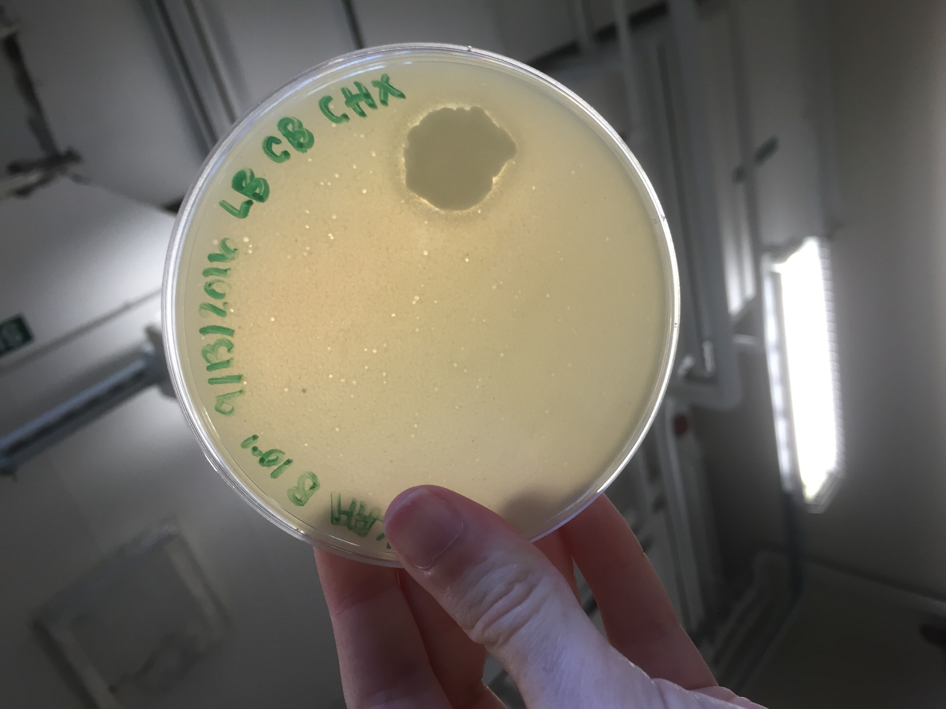

*Figure 19: Serial Dilution B 10^-1*

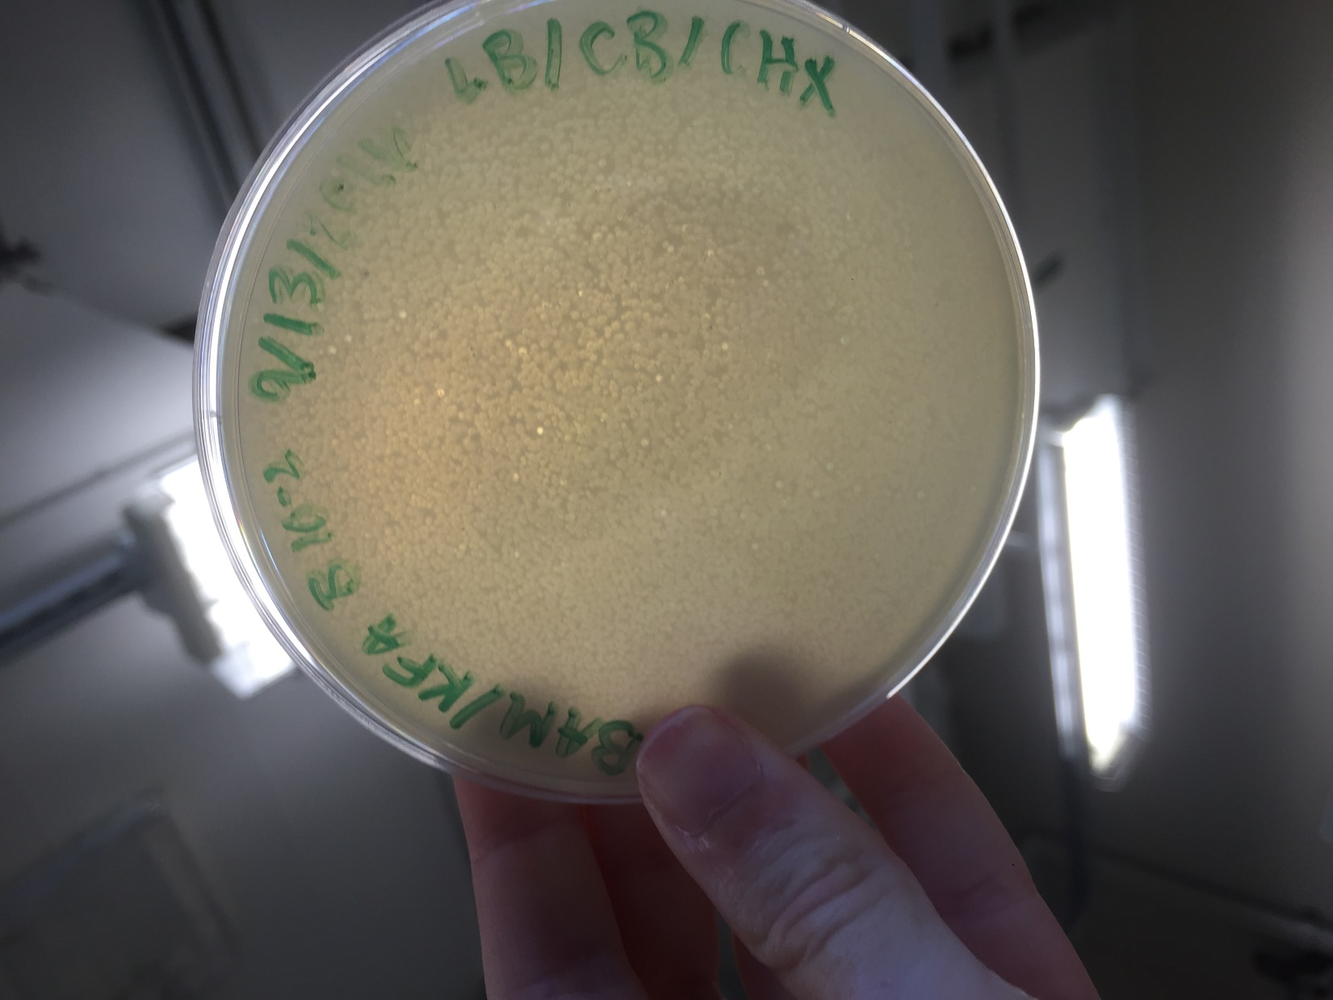

*Figure 20: Serial Dilution B 10^-2*

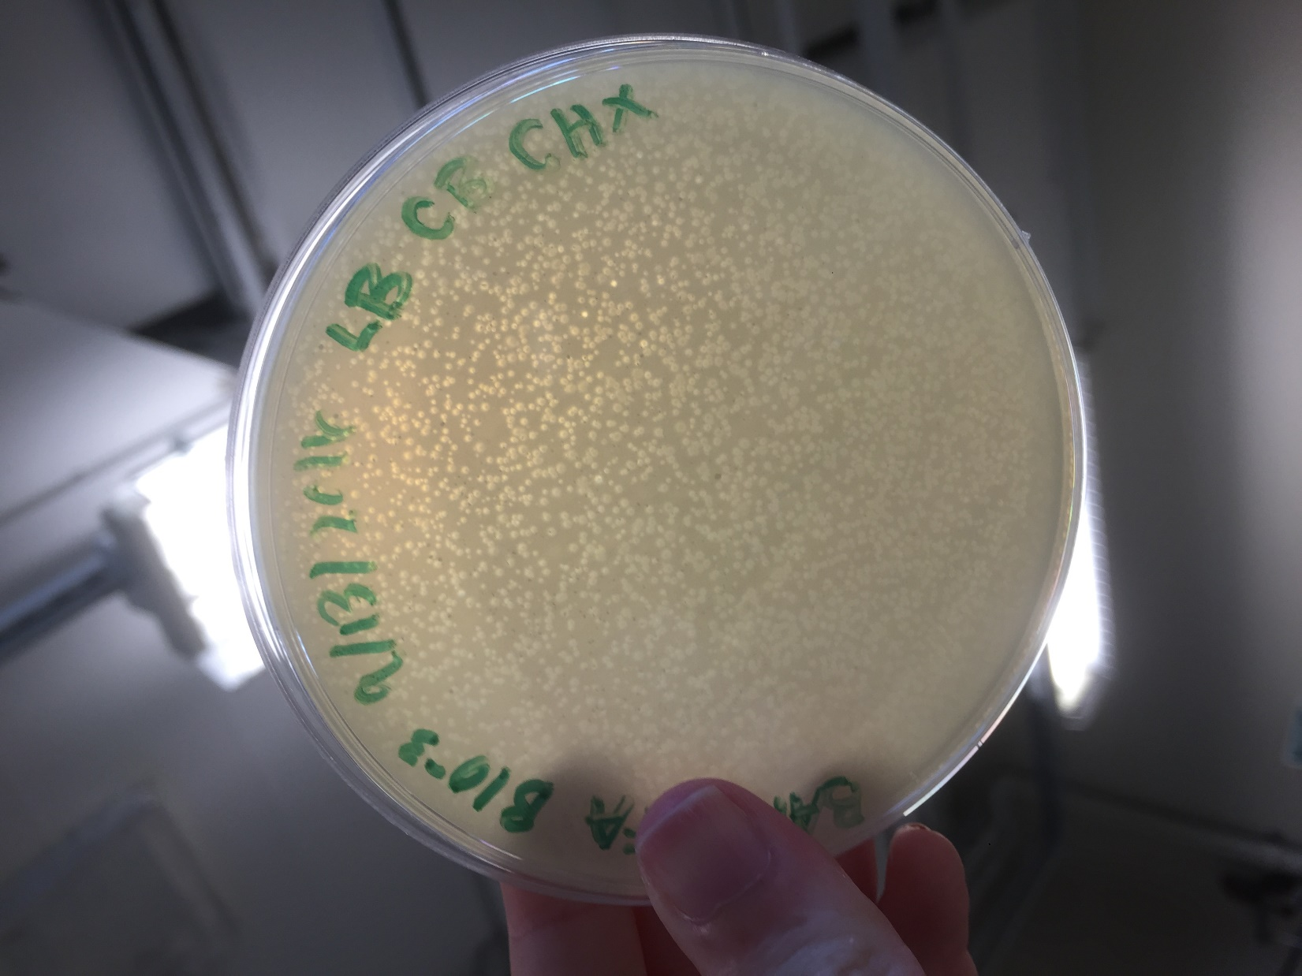

*Figure 21: Serial Dilution B 10^-3*

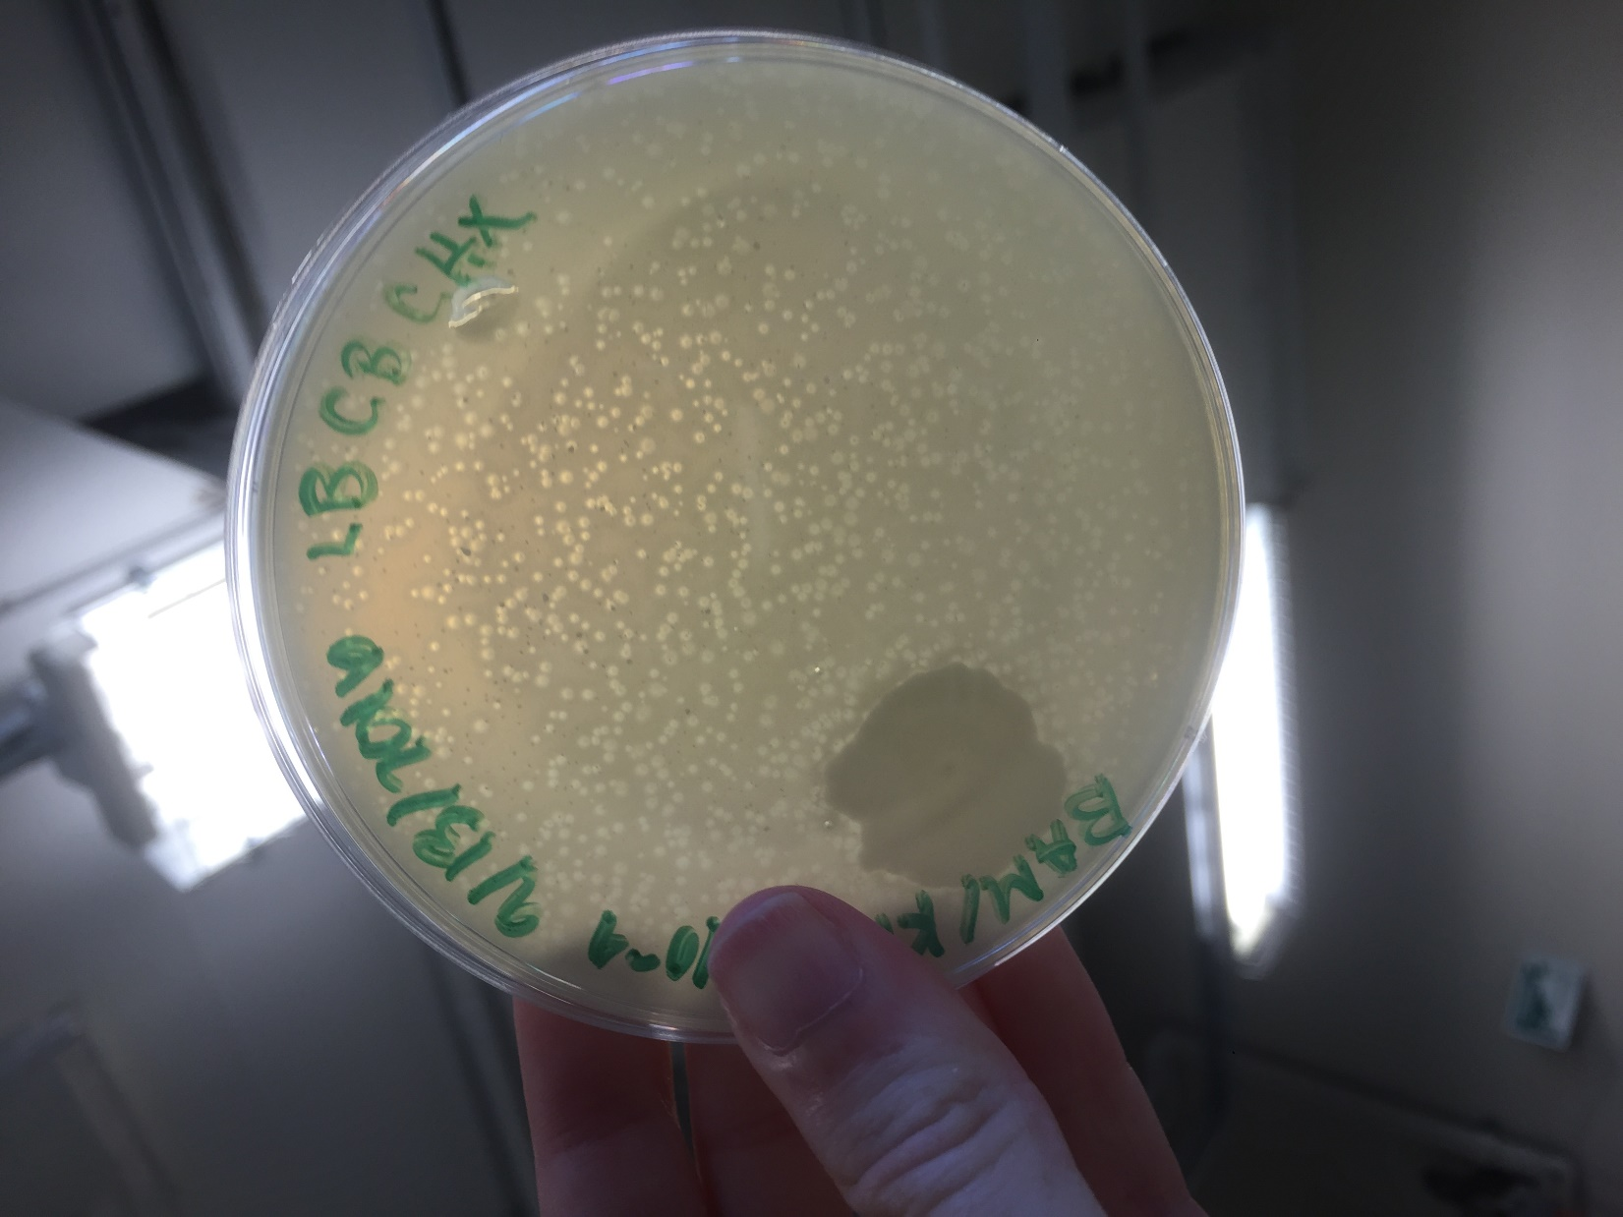

*Figure 22: Serial Dilution B 10^-4*

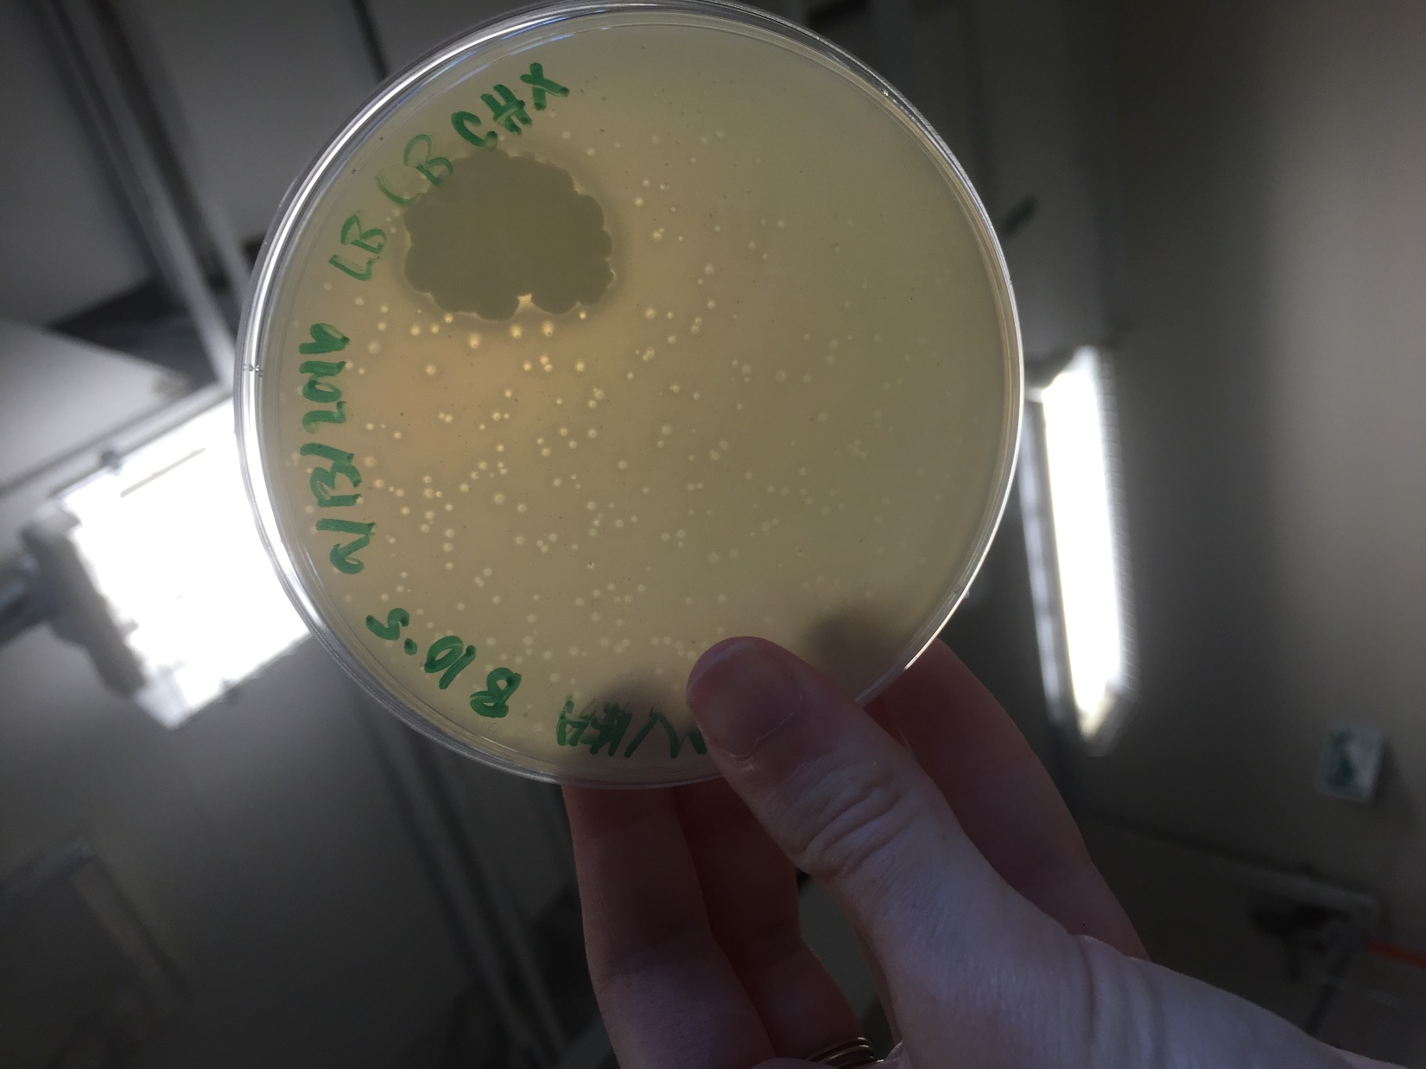

*Figure 23: Serial Dilution B 10^-5*

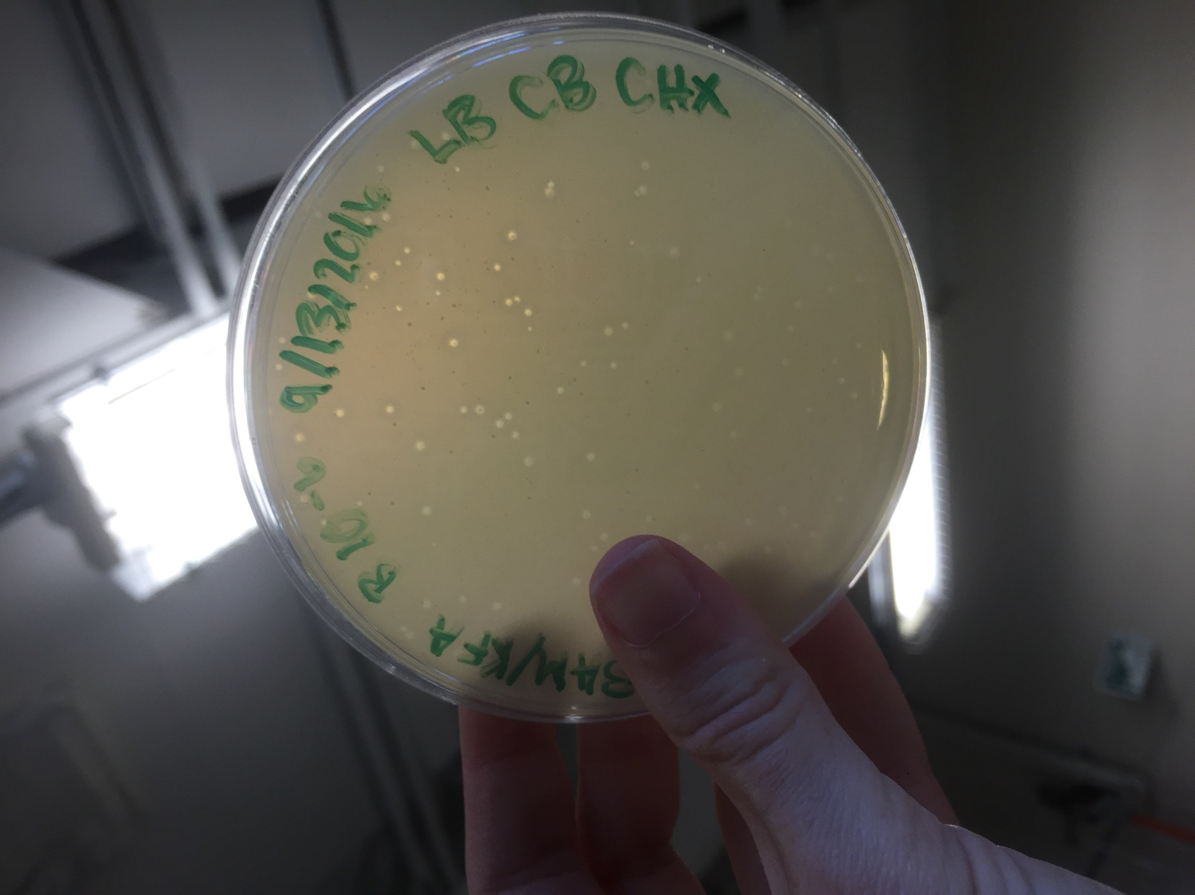

*Figure 24: Serial Dilution B 10^-6*

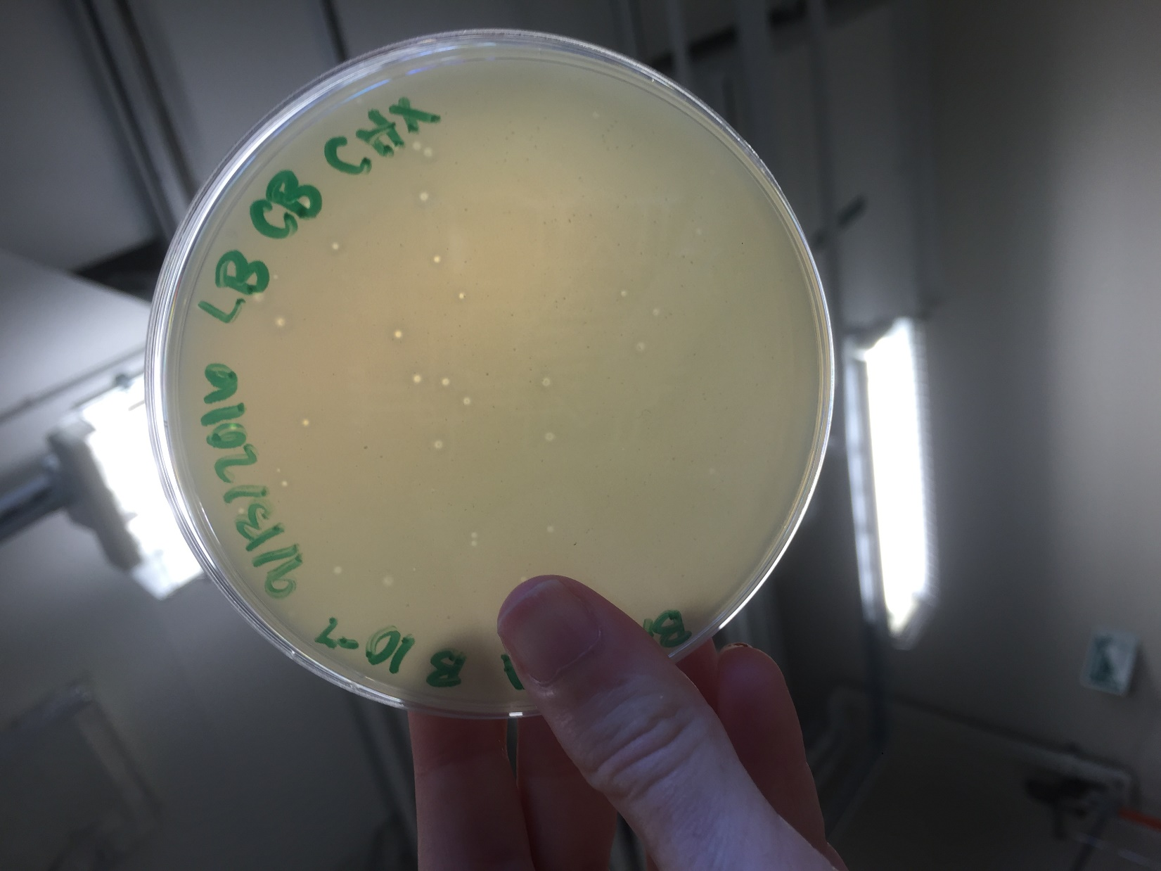

*Figure 25: Serial Dilution B 10^-7*

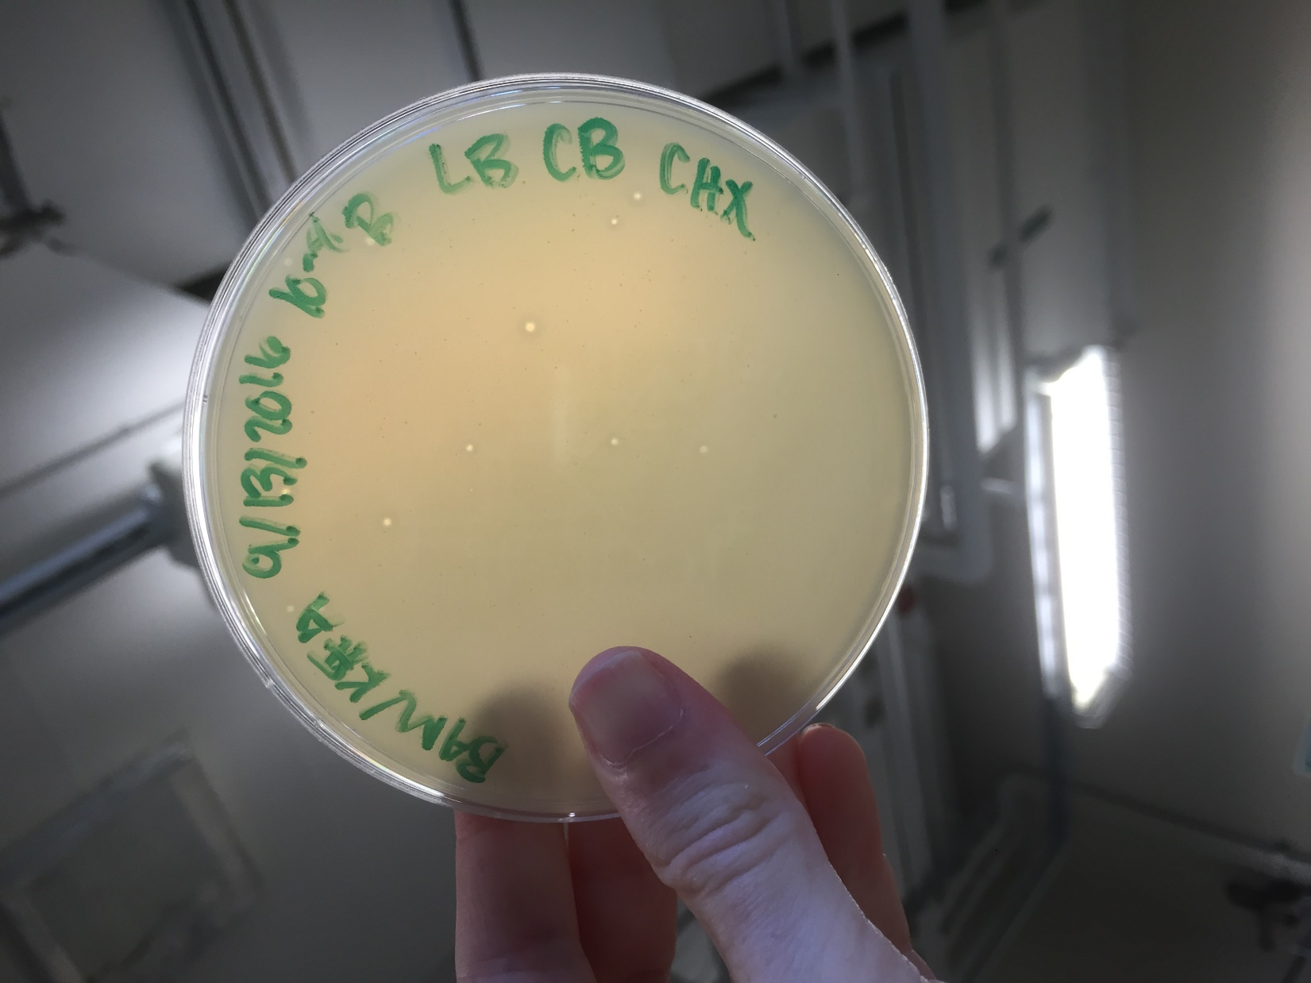

*Figure 26: Serial Dilution B 10^-8*

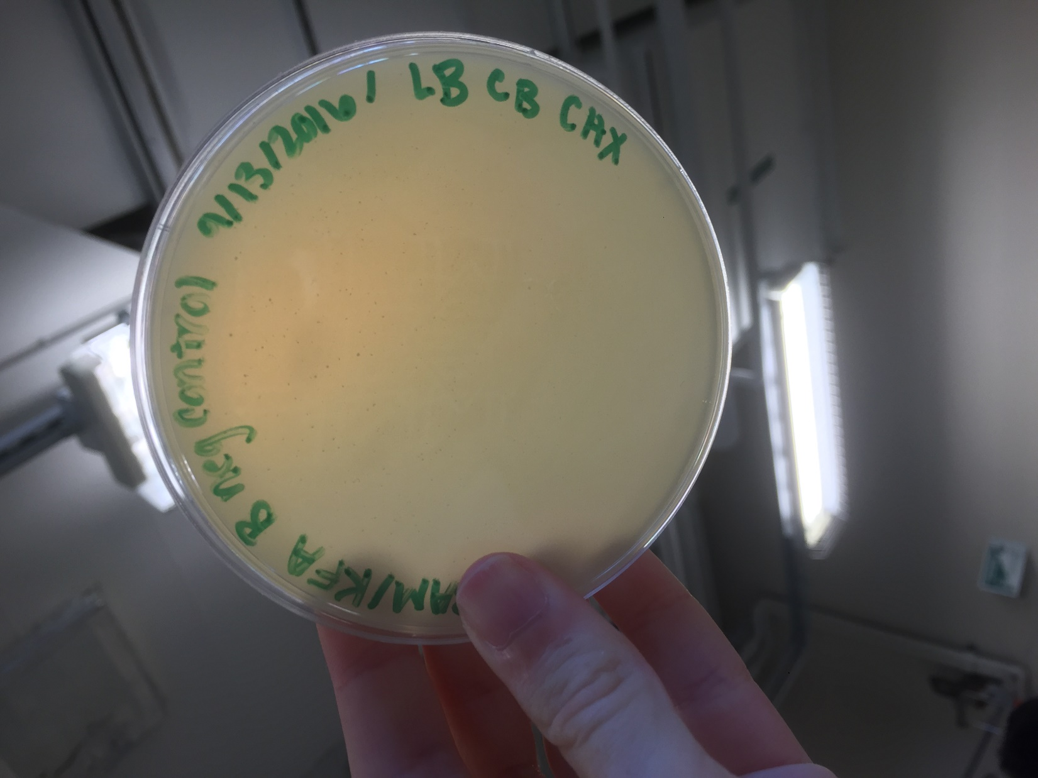

*Figure 27: Serial Dilution B Negative Control*

**Future Actions**

* On Friday, September 16, we will meet with Stephen at 3:30pm to collect the lysate produced by the flooding.

Friday, September 16, 2016

Friday, September 16, 2016

3:30 PM

**Objective**

* Collect the highly concentrated liquid phage sample

**Procedure**

* I followed the Collecting lysates protocols
  + I entered lab, washed my hands, and cleaned up my workspace with the brown detergent and ethanol.
  + Stephen poured out our lysate into the lid of the plate.
  + My partner took out 5 ml of lysate using a syringe and deposited it into the conical tube I held. We repeated this again. (See Data Notes)
  + We put away all of our supplies, cleaned our work bench, and washed our hands.

**Data**

Plate flooded: Sample B, 10^-2 Concentration

Volume collected: 10 ml

**Future Actions**

* On Tuesday, September 20, 2016, the lysate will be used to perform a Spot Titer and a Full Plate Titer.

Tuesday, September 20, 2016

Tuesday, September 20, 2016

11:30 AM

**Objective**

* To prepare liquid phage samples of decreasing concentrations
* Determine the concentration of phage particles in a lysate using a spot test and plaque assay
* Prepare sample for plating and incubation

**Procedure**

* I followed the Spot Titer and Full Plate Titer, Serial Dilution, and Plating a Sample protocols
  + I walked into lab, washed my hands, and cleared my work area with the brown detergent and ethanol.
  + I gathered the supplies needed for the day and my lysate from the refrigerator
  + My partner labeled the agar plates we would be preparing and prepared the bacterial lawn layout
  + We transferred 3ml of agar onto the spot plate and let it harden
  + We then prepared the serial dilutions with the lysate from 10^-1 to 10^-8
  + We infected bacterial cultures with the serial dilutions and allowed them to sit for 10 minutes
  + During that time, we began the spot plate preparation with the serial dilutions. We noticed, however, that the drops of diluted lysate kept moving outside of the desired locations, as the agar was not flat. We disposed of the plate into the biohazard bag and re-prepared the bacterial lawn
  + We then used the plating a sample protocol to plate each of the serial dilutions prepared.
  + Finally, we re-spotted the bacterial lawn, which was flat this time.
  + We put away all of our supplies, cleaned our work bench, and washed our hands.

**Future Actions**

* On Thursday, September 22, 2016, the titer of the lysate will be calculated.
* If the titer is not high enough, webbed plates will be created with the lysate.
* If not, one of the full plate titers will be flooded.

Thursday, September 22, 2016

Thursday, September 22, 2016

11:30 AM

**Objective**

* Determine the titer of the lysate collected

**Procedure**

* I calculated the titer of my lysate and the volume of lysate needed to create a webbed plate today.
  + I walked into lab, washed my hands, cleaned my lab bench, and gathered the plates my partner and I made last time.
  + My partner and I examined the plates, recorded observations, and took photos of the plates (see Data Table 6 & 7, and Figures 28 - 37)
  + We then calculated the titer, as seen in the Data Tables. The titer was determined to be 6.4*10^6.
    - This is too low to flood the plate directly, so a webbed plate must be developed.
  + My partner and I then worked on calculating how much of our lysate would be needed to create a webbed plate, then multiplied that volume by 1/5, 1/2, 2, and 5.
    - We determined that we would have to dilute our lysate by 100 and pipette 6.4 microL of that solution
  + We cleaned our workbench and washed our hands

**Data**

*Table 6: Spot Titer Data*

|  |  |  |  |
| --- | --- | --- | --- |
| Spot | Description | Number of Plaques | Titer Calculation |
| Negative Control | Clear of plaques | 0 | N/A |
| 10^-1 | One large plaque, about 1/2 inch across | 1 | uncountable |
| 10^-2 | Two large plaques, about 1/4 inch across | 2 | uncountable |
| 10^-3 | One plaque, about 1/4 inch across | 1 | uncountable |
| 10^-4 | Five small plaques, from 1/8th inch - 1/16th inch across | 5 | 1.67*10^7 |
| 10^-5 | A few very small plaques, about 1 mm across | 7 | 2.33*10^8 |
| 10^-6 | Two plaques, about 1/8th inch across | 2 | 6.7*10^10 |
| 10^-7 | Three small plaques, 1/8th inch across | 3 | 1*10^10 |
| 10^-8 | One plaque, 1/8th inch across, made up of three smaller plaques in a clover shape | 3 | 1*10^11 |

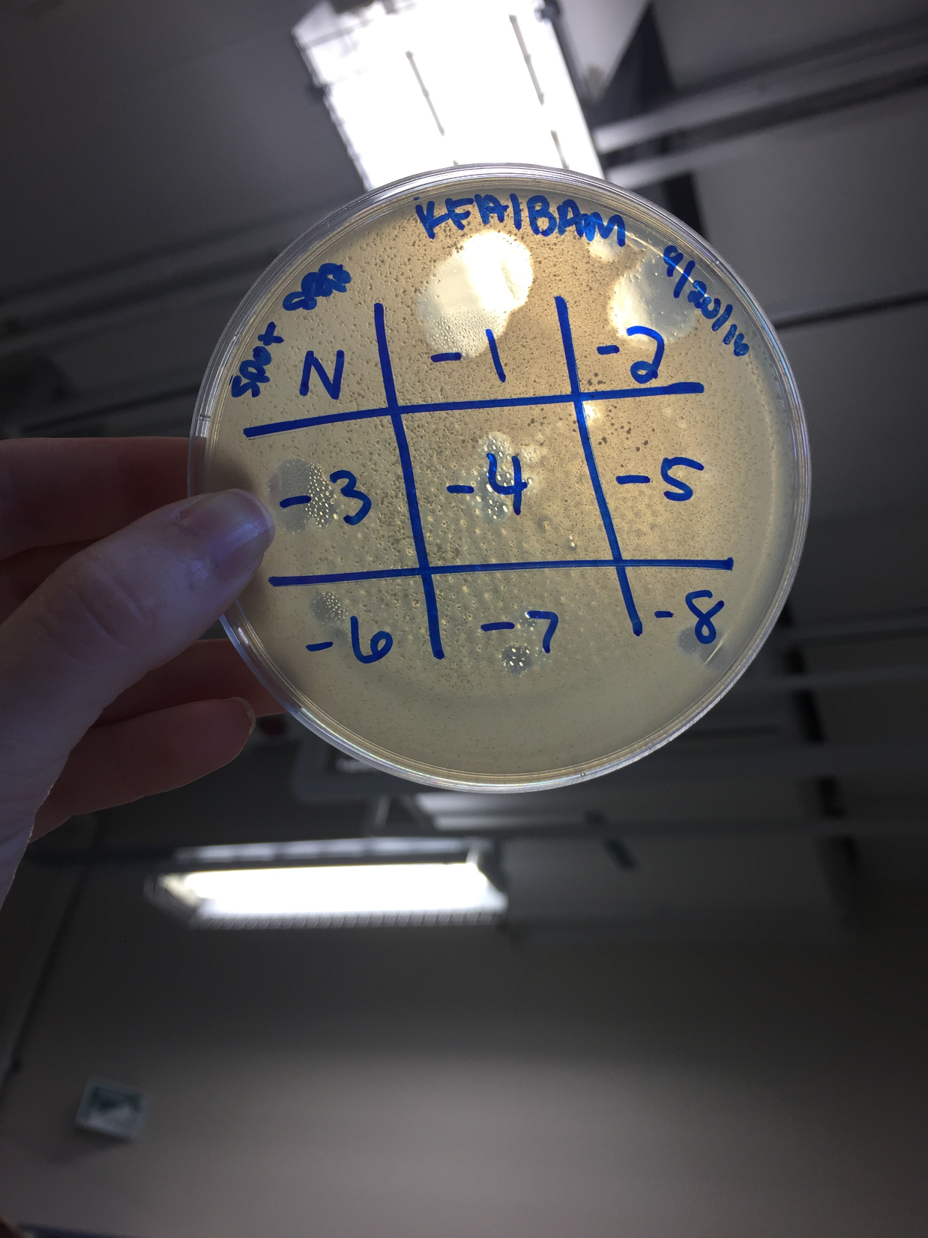

*Figure 28: Spot Titer Plate*

*Table 7: Full Plate Titer Data*

|  |  |  |  |
| --- | --- | --- | --- |
| **Dilution** | **Description** | **Number of Plaques** | **Titer Calculation** |
| Negative control | Clear of plaques | 0 | N/A |
| 10^-1 | Agar is nearly completely clear from plate | Uncountable | infinity |
| 10^-2 | Agar is nearly clear from plate, not quite to the degree of 10^-1 plate | 640 +/-80 | 6.4*10^6 |
| 10^-3 | A few dark contamination spots, but many clear plaques, about 1/8th inch across, along with many very small, clear plaques, about 1/2 mm across | 60 | 6*10^6 |
| 10^-4 | Some clear plaques, about 1/4 inch across | 35 | 3.5*10^7 |
| 10^-5 | Many very small plaques, about 1/2 mm across | 1 | 1*10^7 |
| 10^-6 | Some dark contamination spots, but a few plaques | 6 | 6*10^8 |
| 10^-7 | One clear plaque, a few cloudy spots | 1 | 1*10^9 |
| 10^-8 | Many air bubbles, no plaques | 0 | 0 |

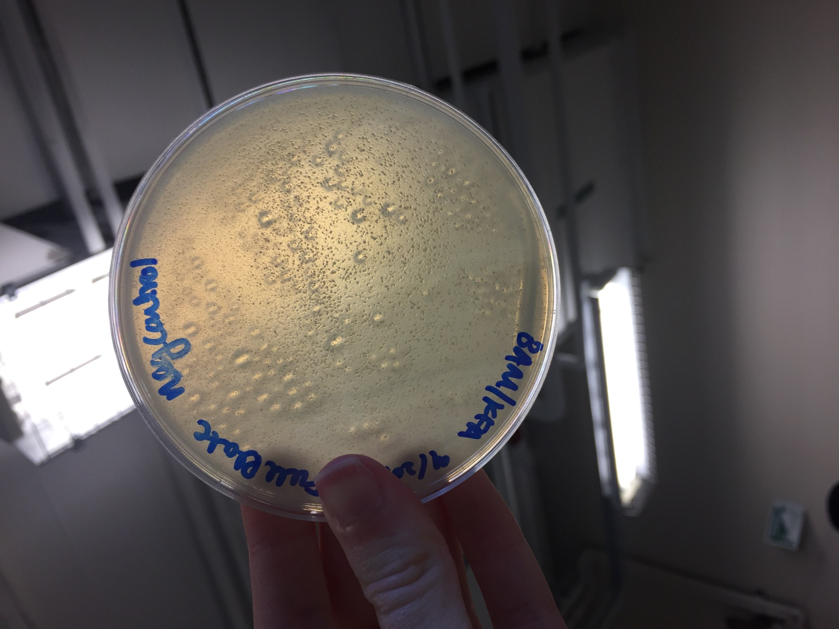

*Figure 29: Negative Control Full Plate Titer*

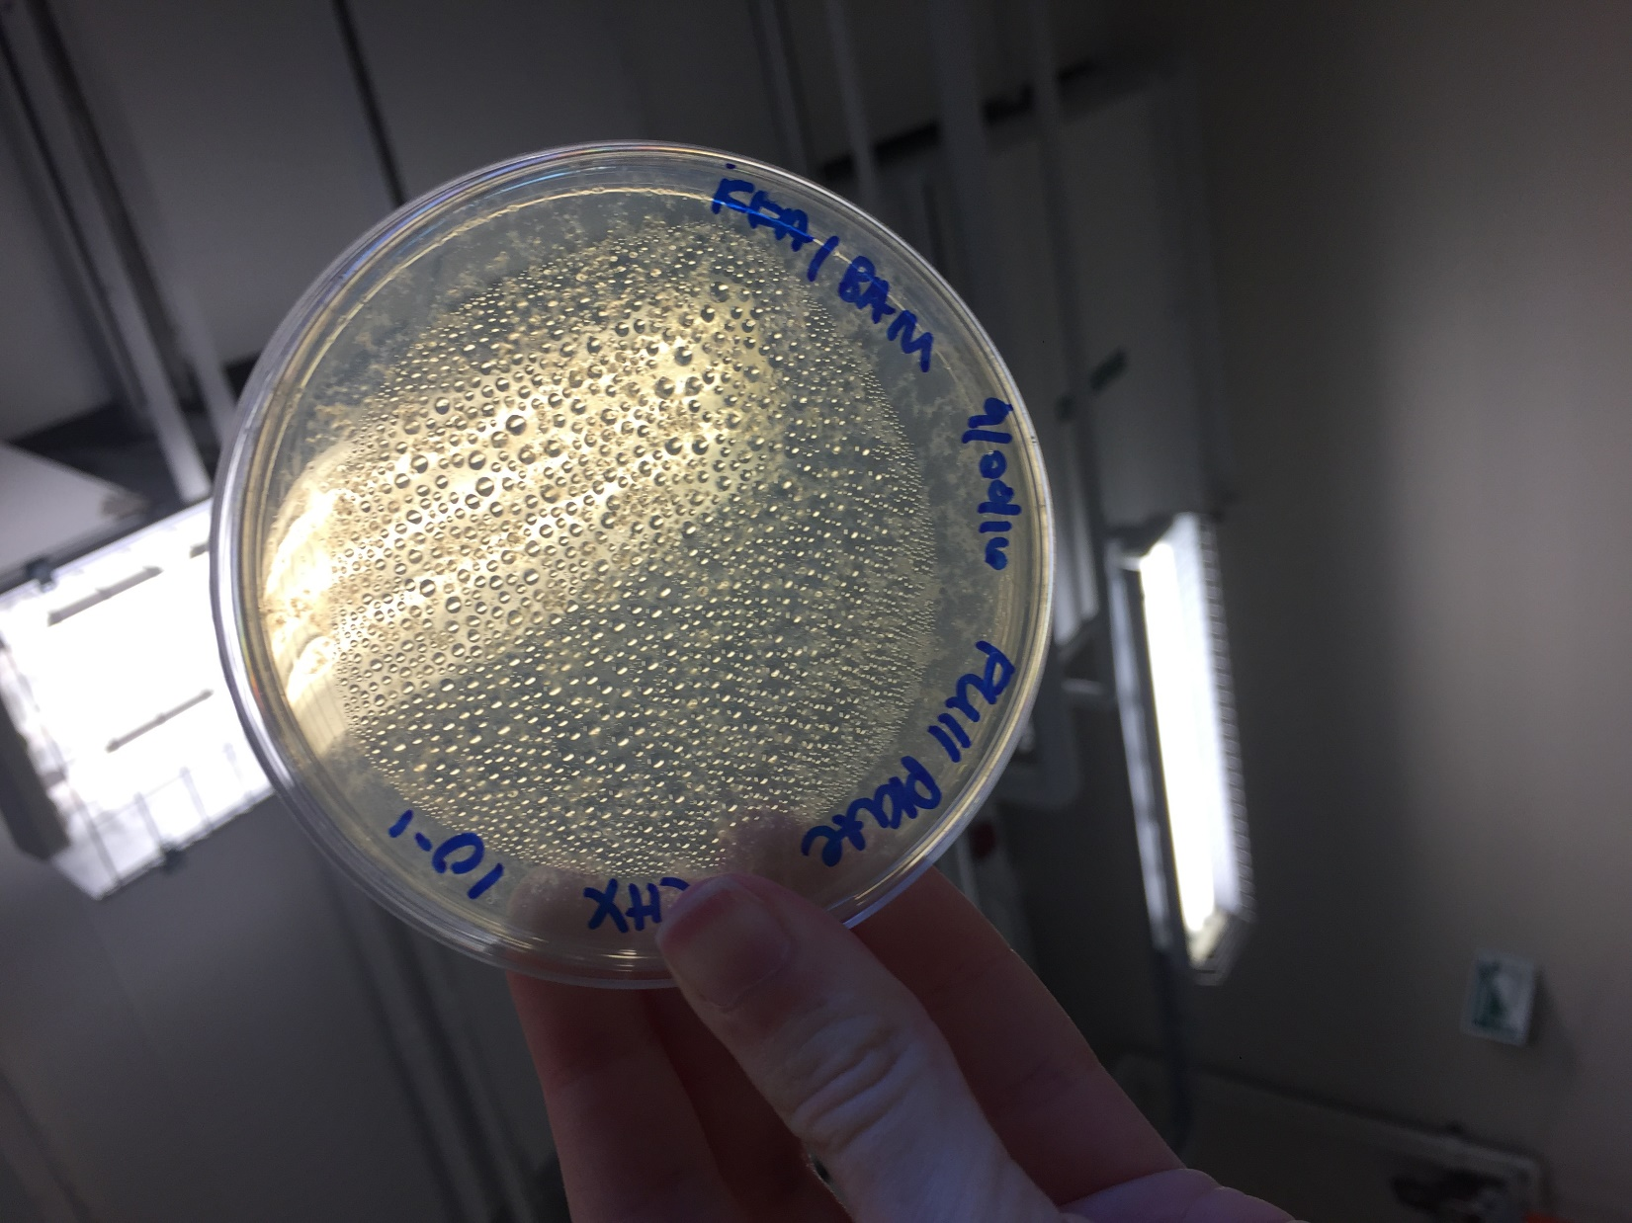

*Figure 30: 10^-1 Full Plate Titer*

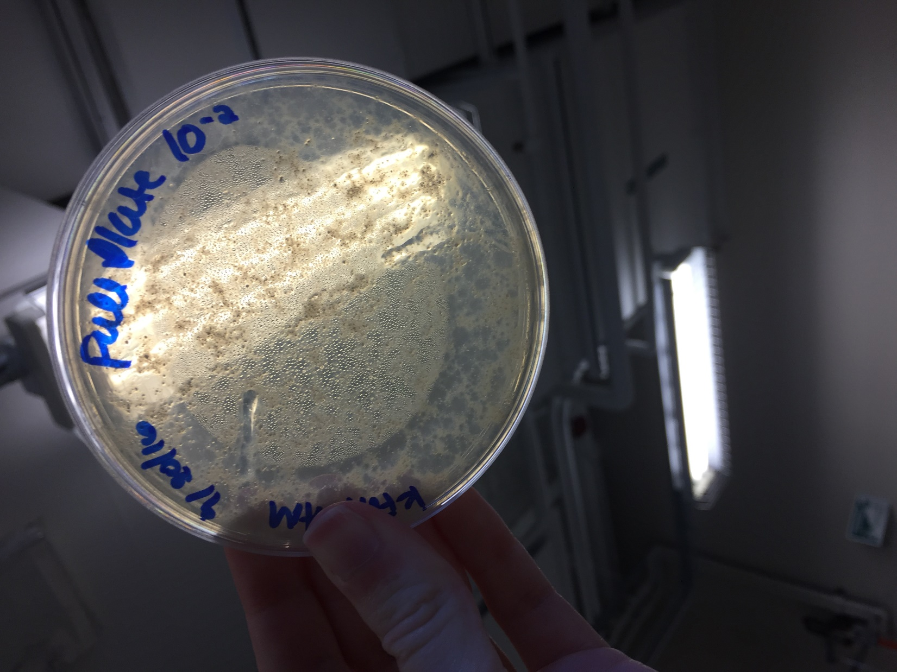

*Figure 31: 10^-2 Full Plate Titer*

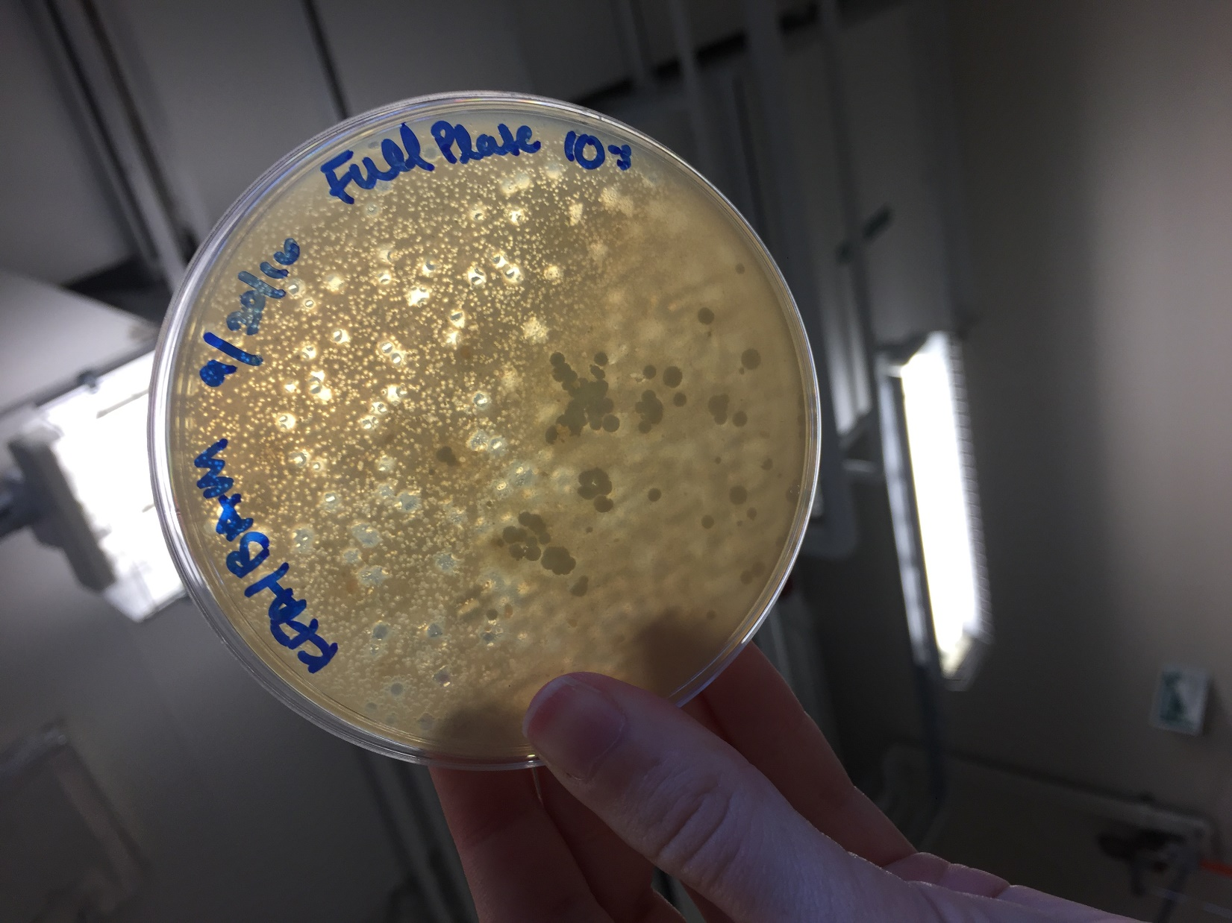

*Figure 32: 10^-3 Full Plate Titer*

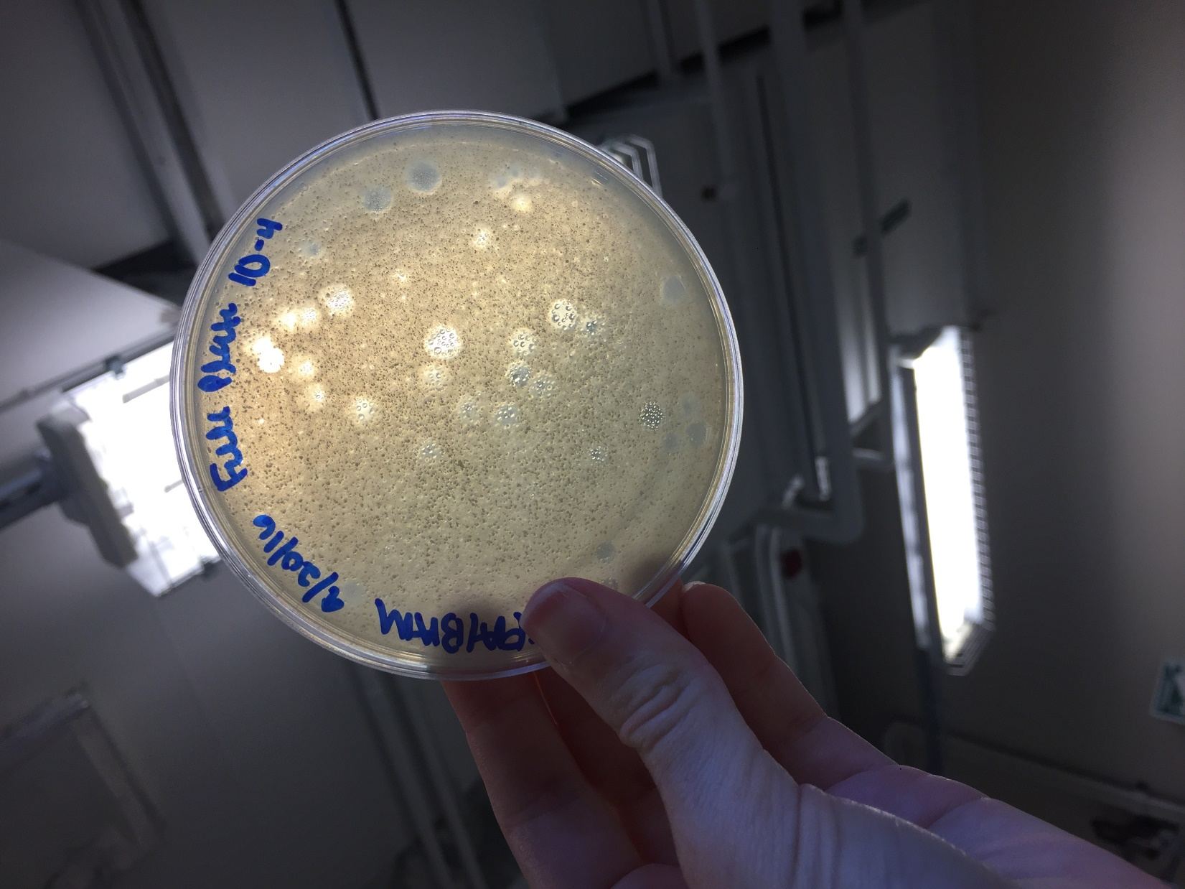

*Figure 33: 10^-4 Full Plate Titer*

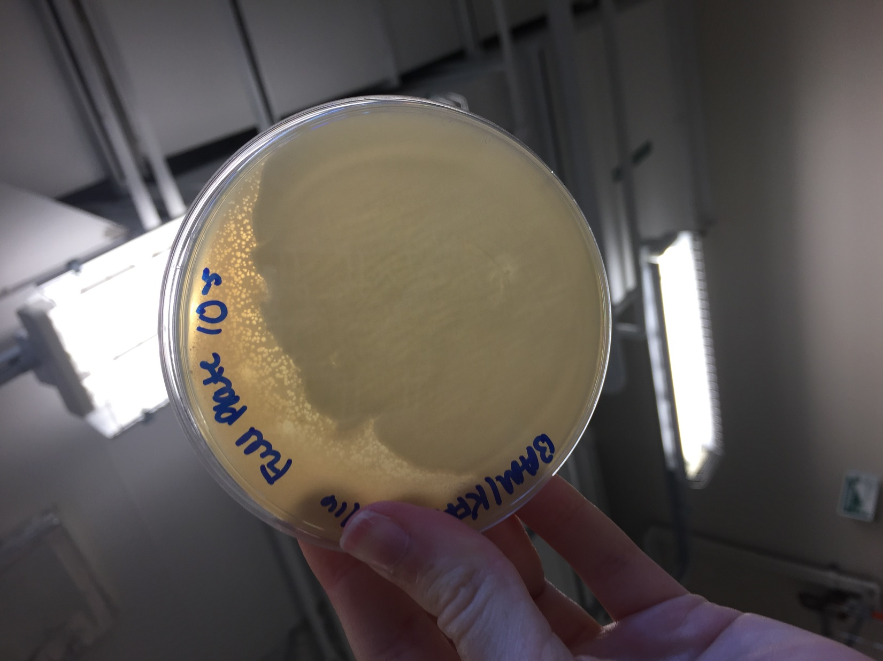

*Figure 34: 10^-5 Full Plate Titer*

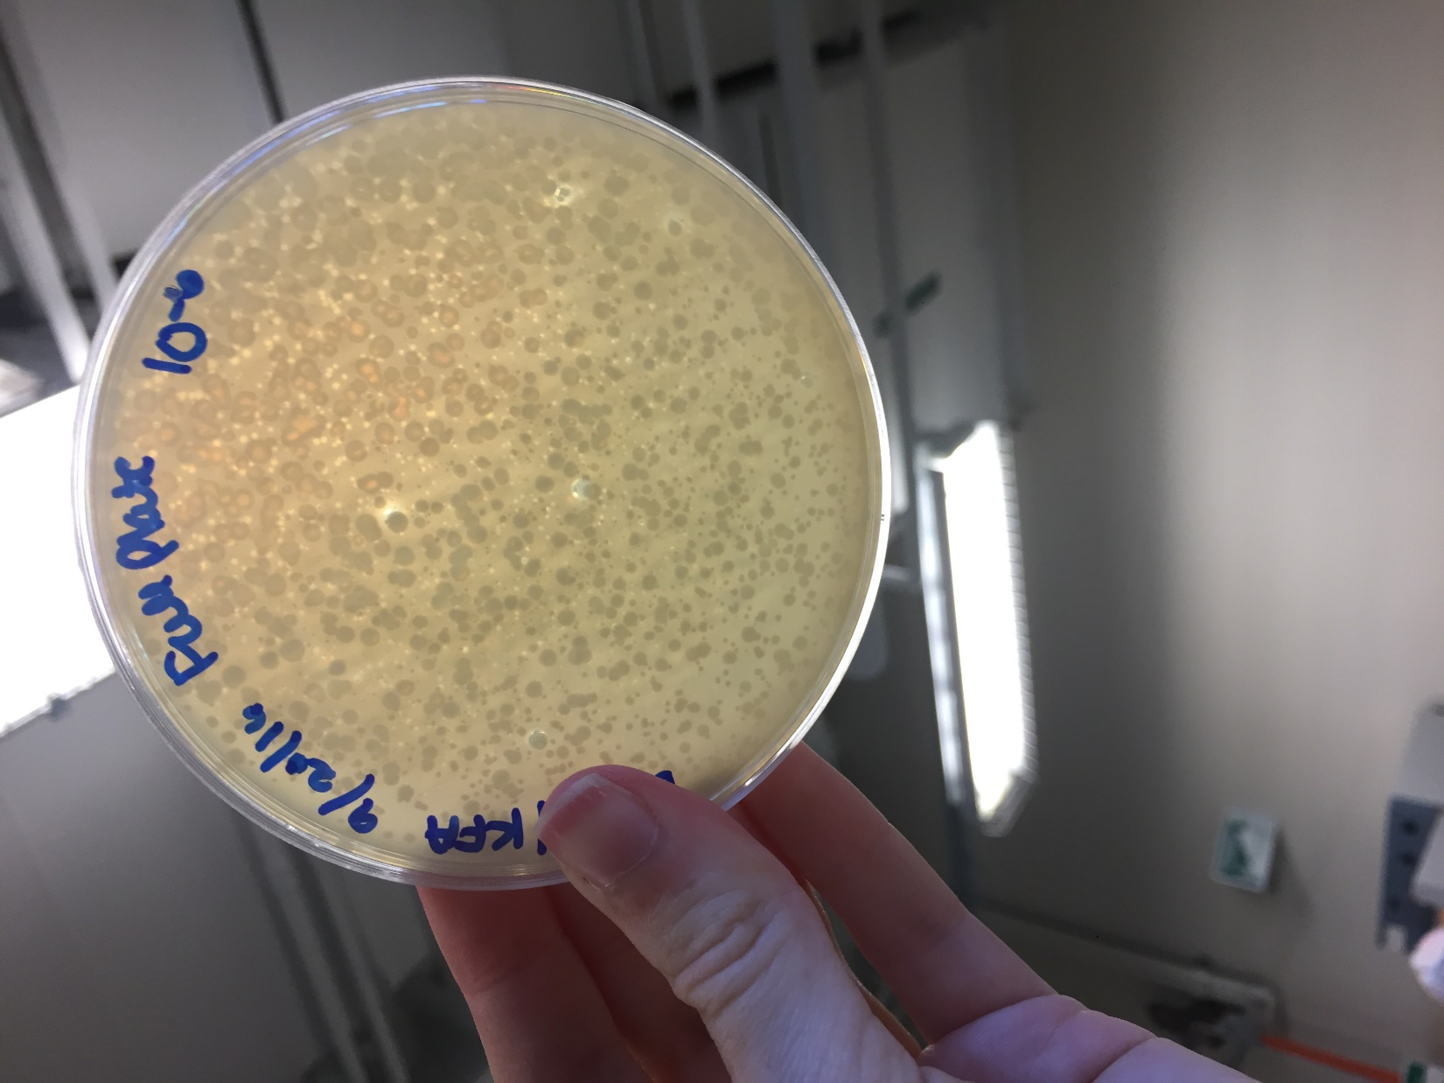

*Figure 35: 10^-6 Full Plate Titer*

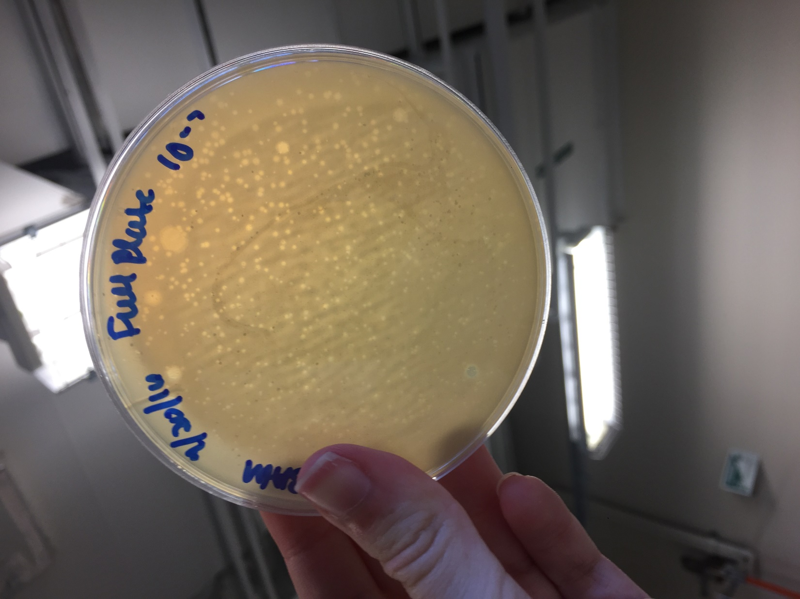

*Figure 36: 10^-7 Full Plate Titer*

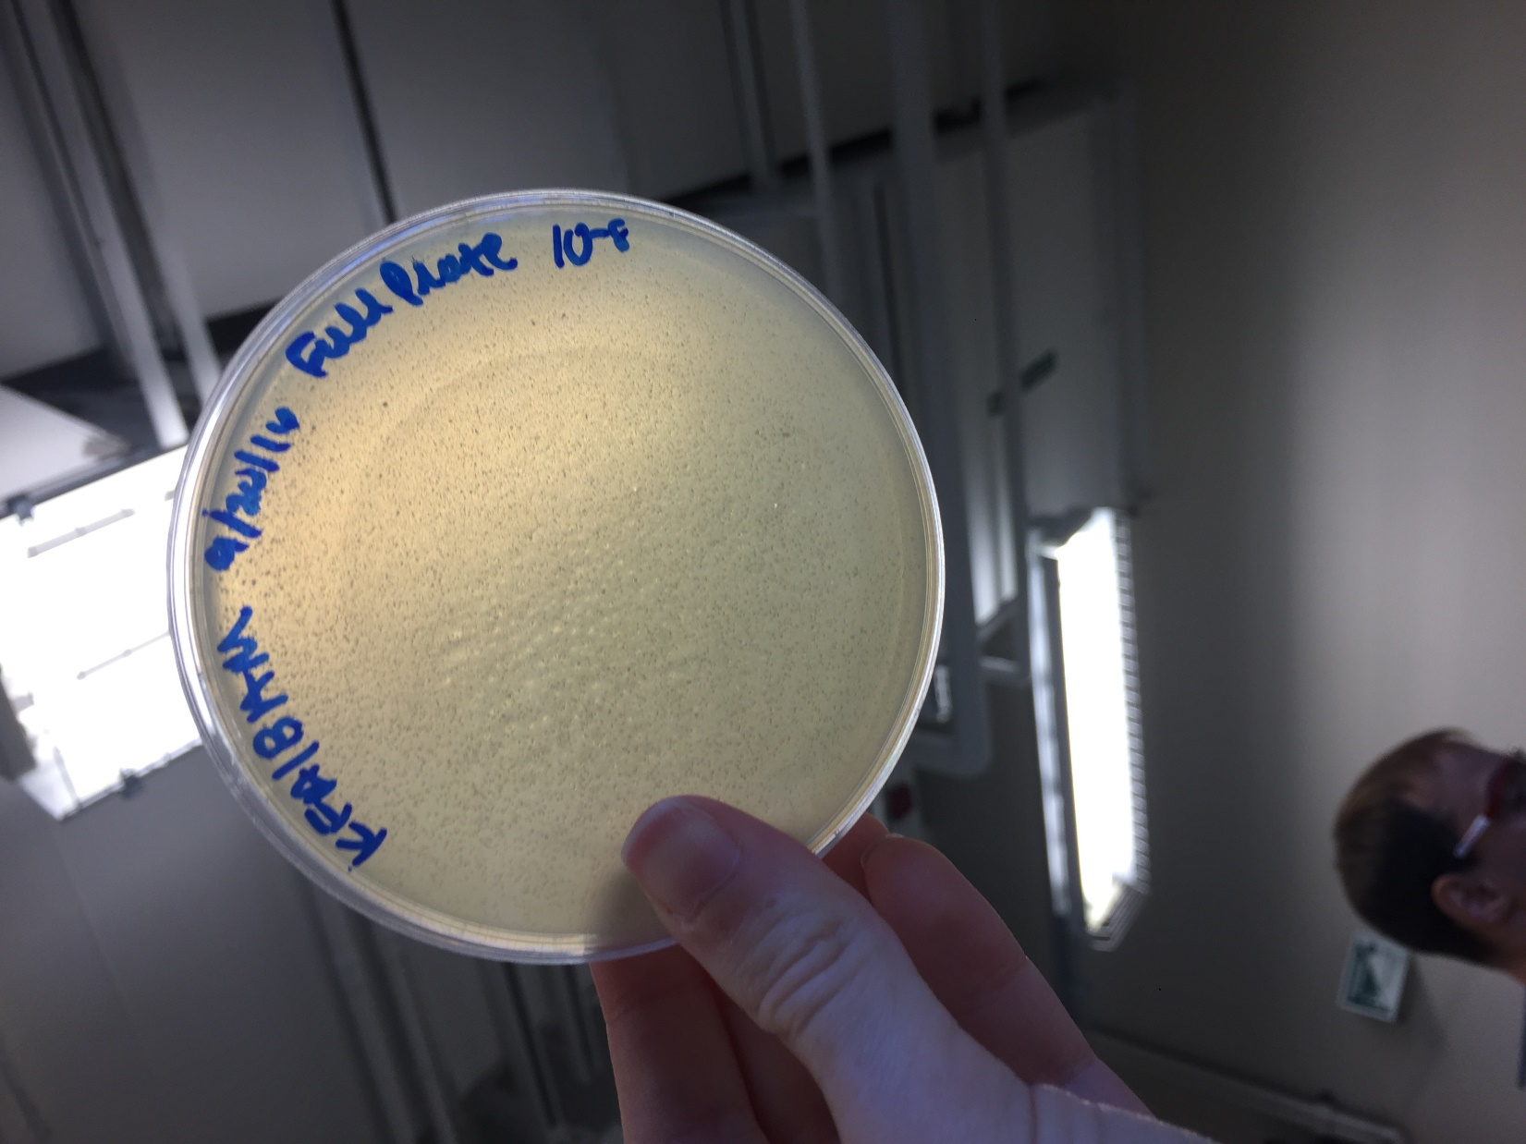

*Figure 37: 10^-8 Full Plate Titer*

**Future Actions:**

* On Tuesday, September 27, 2016, a 10^-2 dilution of the lysate will be prepared and different volumes of the lysate will be pipetted to create a webbed plate, as well as webbed plates with the estimated webbed plate volume multiplied by 2, 5, 1/2 and 1/5.

Tuesday, September 27, 2016

Tuesday, September 27, 2016

11:30 AM

**Objective**

* To prepare liquid phage samples of decreasing concentrations
* Create a plate with a very high density of plaques from a lysate of known titer
* Prepare sample for plating and incubation

**Procedure**

* I followed the serial dilution, making webbed plates from a lysate of known titer, and plating a sample protocols
  + I walked into lab, washed my hands, and cleaned my work bench with the brown detergent and ethanol
  + I gathered all the materials we needed for the day
  + My partner and I performed a 10^-2 serial dilution
  + We used 6.4 microL as the original volume of the 10^-2 serial dilution to make webbed plates of 1/5, 1/2, 1, 2, and 5 times the original volume.
  + We allowed the volumes of the lysate to infect bacteria samples, then plated the samples
  + We cleaned up our workspace and washed our hands.

**Future Actions**

* On Thursday, September 29, 2016, the best webbed plates will be flooded to obtain a high volume lysate.

Thursday, September 29, 2016

Thursday, September 29, 2016

11:30 AM

**Objective**

* Generate well-isolated plaques containing only one kind of phage

**Procedure**

* I followed the Streak Plate Process today
  + I walked into lab, washed my hands, and cleaned my workspace with the brown detergent and ethanol.
  + I retrieved the plates my partner and I made last time.
  + My partner and I inspected the plates, recorded our observations, and took photos of the plates. (See Table 8 & Figures 38 - 42)
    - We found two types of plaques on our webbed plates: some small and some large, so we decided to make steak plates to determine whether or not these plaque morphologies come from the same phage.
  + We gathered the supplies we needed for the day, then marked the OV/5 plate's plaques that we planned to pick to create the streak plates
  + We also wrapped up our OV/2 and OV plates in case we can flood them next time.
  + We created the streaks for the negative control to practice the technique of streaking.
  + We then picked the marked large plaque and streaked with the plaque to create the large plaque's streak plate and repeated the procedure with the small plaque we had marked.
  + We retrieved our agar and put 3ml of it into each of our 3 bacteria samples, vortexed the mixtures, then poured the mixture over the spots we had marked where the last streak ended on each plate.
  + We put everything away, cleaned our workspace, then washed our hands.

**Data**

*Table 8: Webbed Plate Observations*

|  |  |  |
| --- | --- | --- |
| Plate Volume | Description | Flooded? |
| OV/5 | Countable number of plaques, but very clear plate | N/A |
| OV/2 | Also countable number of plaques, more clear than OV/5 | N/A |
| OV | Many plaques, nearly uncountable, as there are so many that run together; very clear plate | N/A |
| 2OV | Nearly entirely clear plate | N/A |
| 5OV | Clear plate, with few very small clouds | N/A |

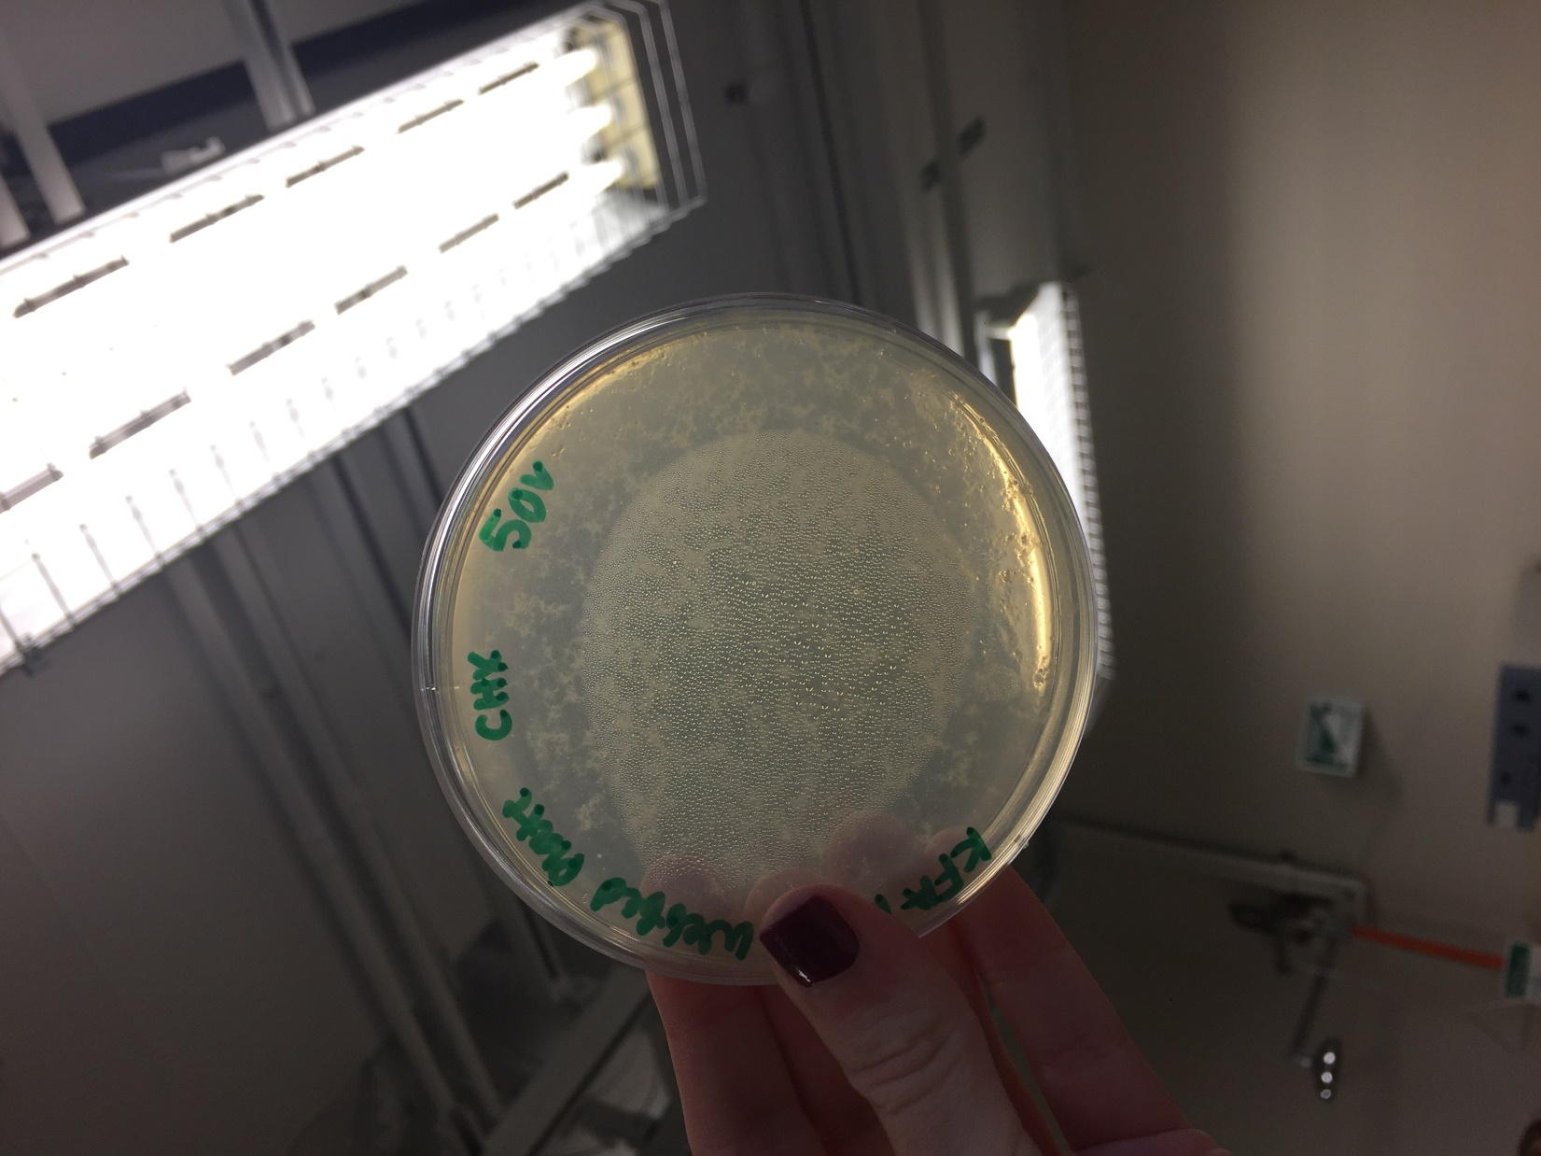

*Figure 38: Webbed Plate with OV * 5*

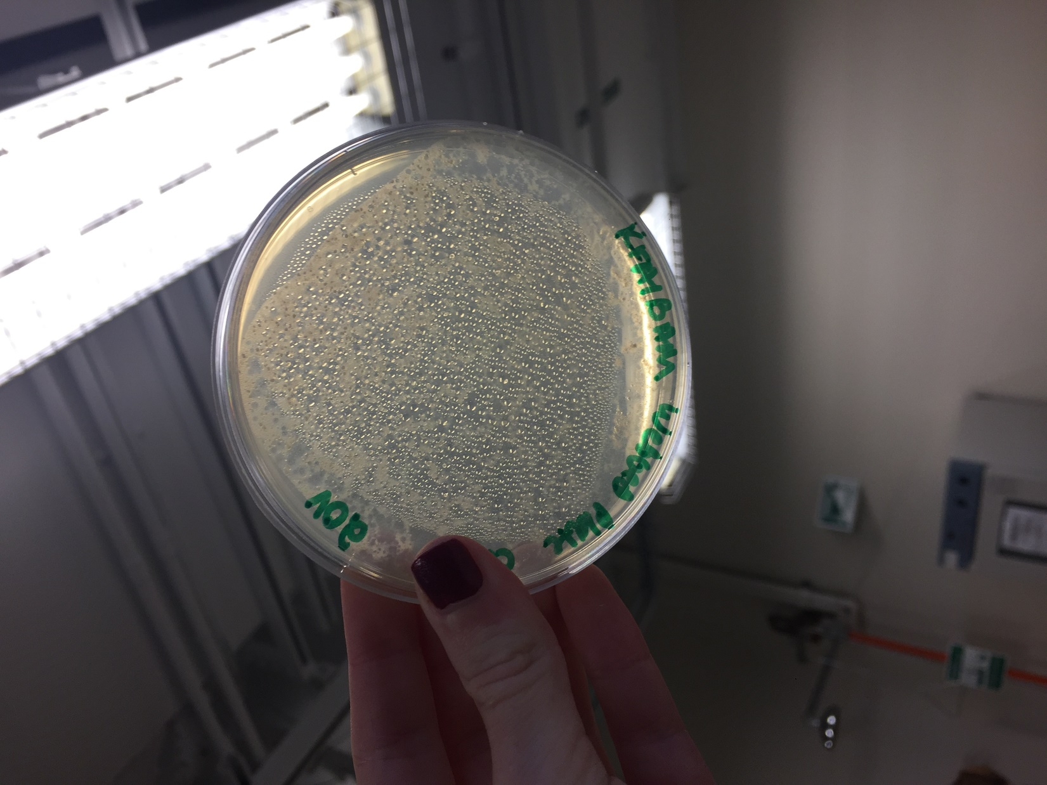

*Figure 39: Webbed Plate with OV * 2*

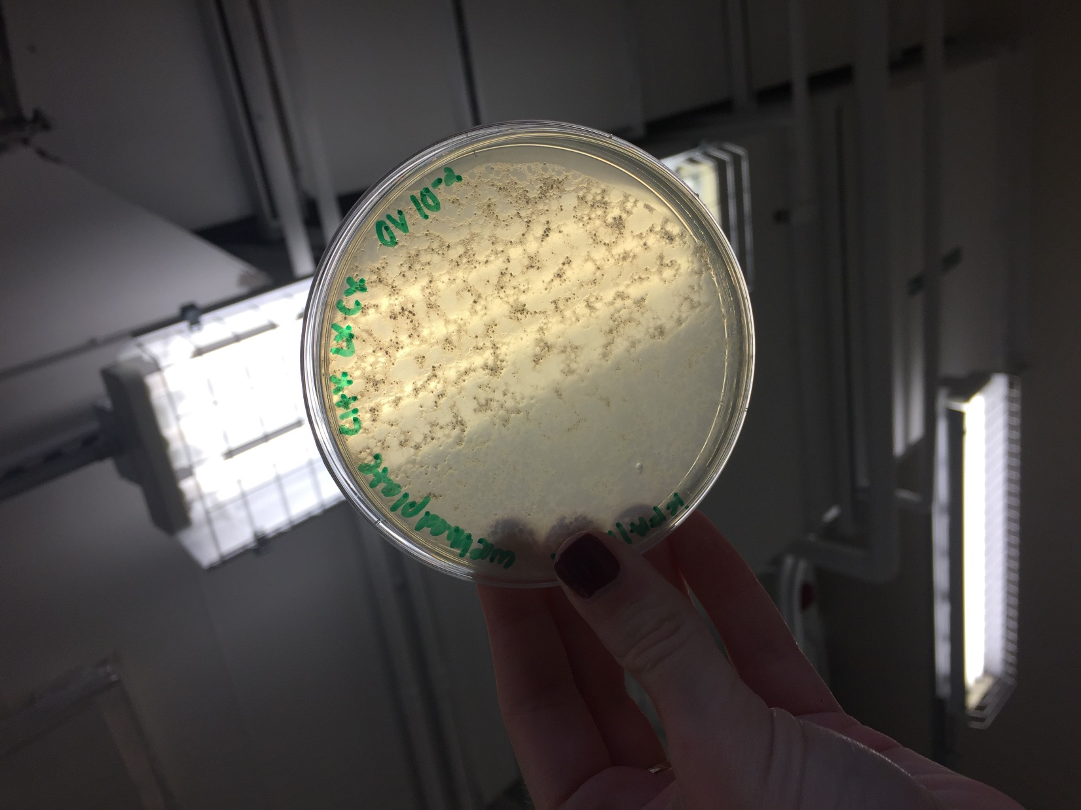

*Figure 40: Webbed Plate with OV*

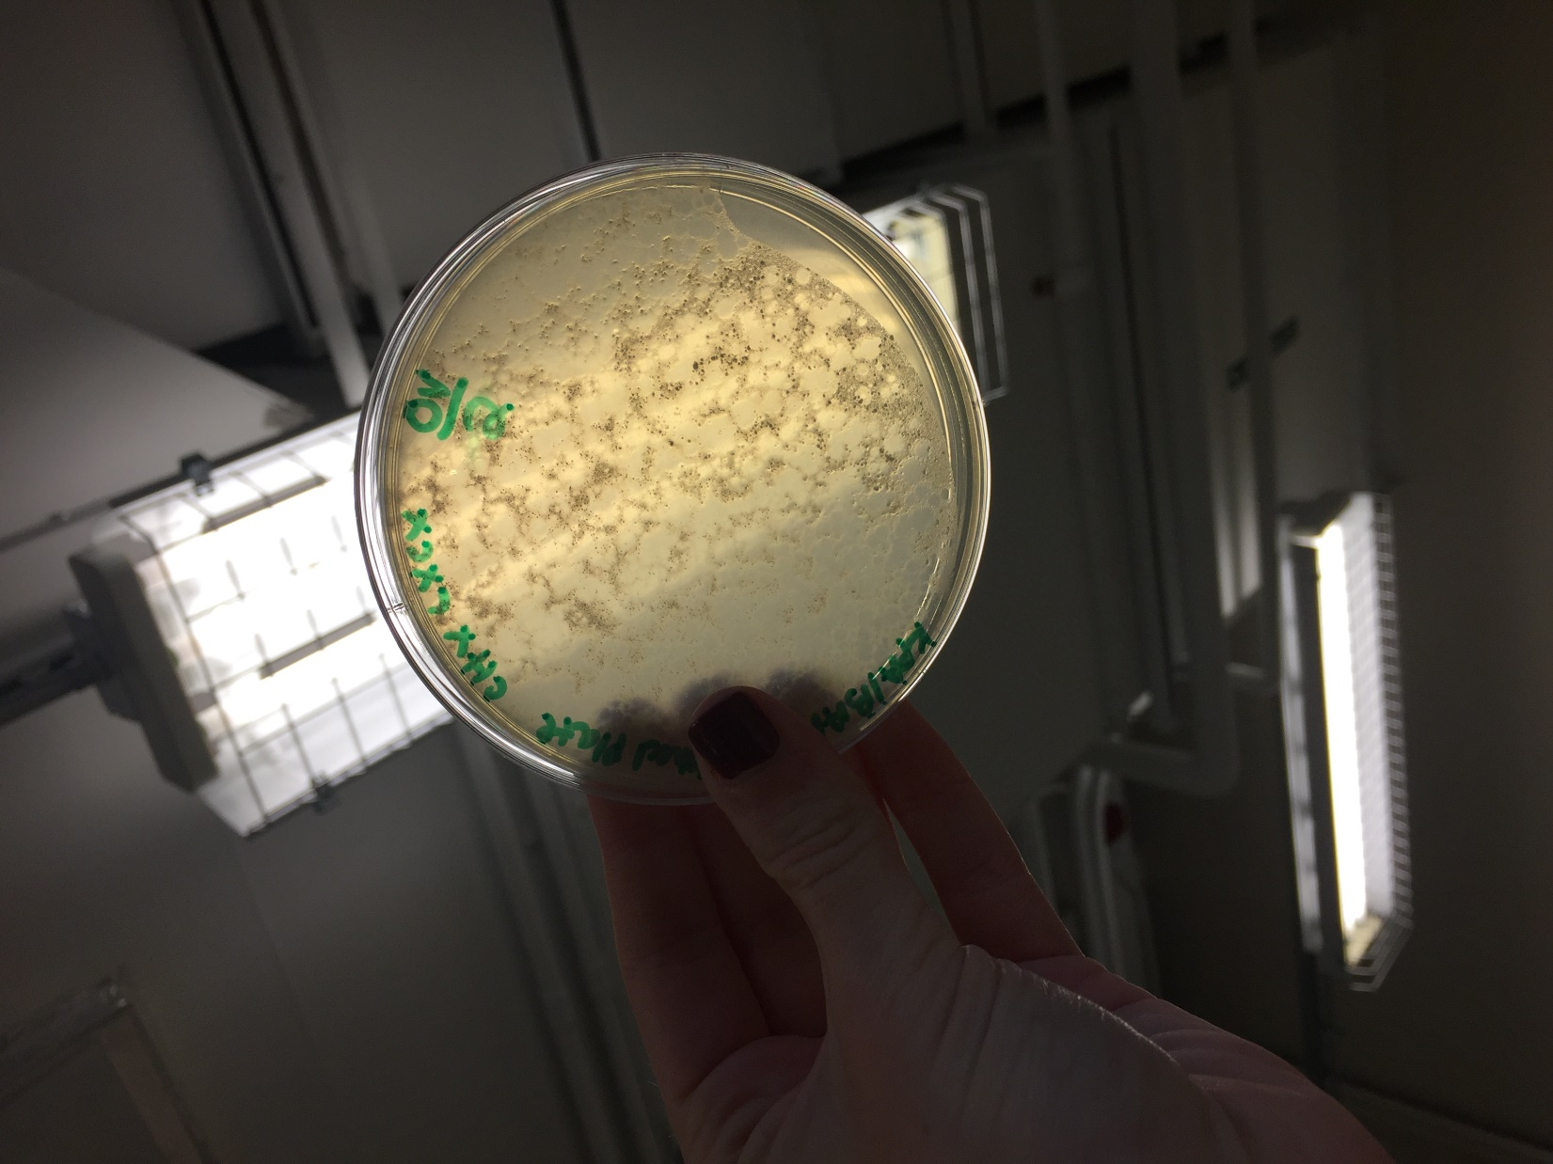

*Figure 41: Webbed Plate with OV / 2*

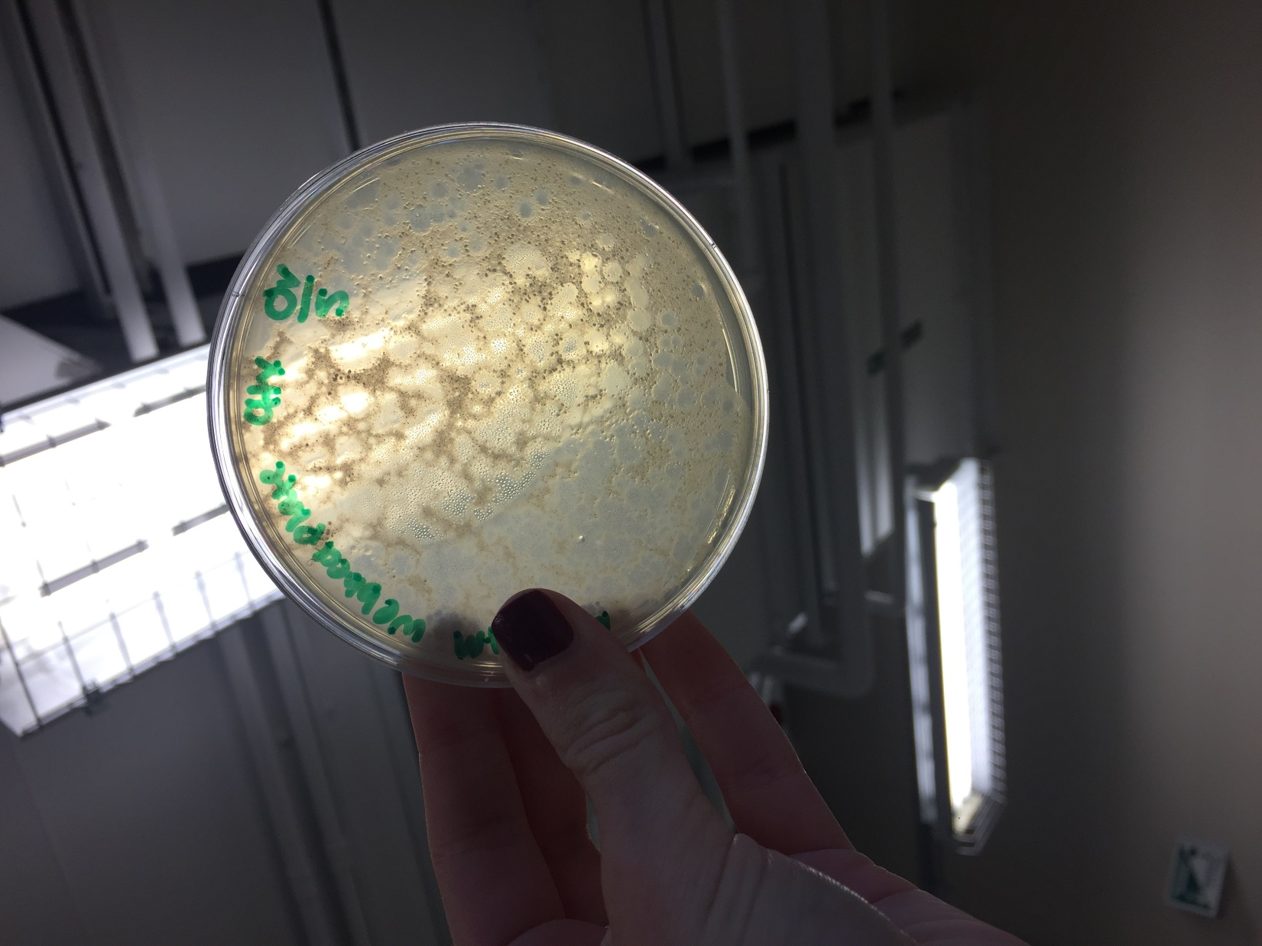

*Figure 42: Webbed Plate with OV / 5*

**Future Actions**

* On Tuesday, October 4, 2016, we will inspect the streak plates to determine whether or not the two plaque morphologies come from the same phage.
* If they are from the same phage, we will flood one of the webbed plates.
* If not, we will pick a plaque and create serial dilutions.

Tuesday, October 4, 2016

Tuesday, October 4, 2016

11:30 AM

**Objective**

* Generate a highly concentrated liquid phage sample

**Procedure**

* I followed the plate flooding procedure today.
  + I entered lab, washed my hands, and cleaned my work bench with the brown detergent and ethanol.
  + I retrieved the streak plates my partner and I had made last time.
  + My partner and I inspected them, recorded our observations, and took pictures of the plates. (See Table 9 and Figures 43-45)
    - We determined that the plaques do come from the same phage, so we can flood the plates we saved last time today.
  + My partner and I added 8 ml of phage buffer to each of the two plates we had saved.
  + We made an appointment with Stephen to retrieve the lysate for Wednesday, October 5, 2016 at 11:30 am.
    - I have a class at this time, so my partner will go to this alone. Stephen okayed this, as retrieving lysate is not a very big job and can easily be done by one person with his help.
  + We cleaned up our workspace and washed our hands.

**Data**

*Table 9: Streak Plate Observations*

|  |  |
| --- | --- |
| Plate | Observations |
| Negative Control | No plaques, but a lack of agar due to no swirling on one side of the plate |
| Big Plaque | There are plaques over the plate, except the least dilute streaks. Large plaques about 1/4 of an inch in diameter |
| Small Plaque | There are plaques over the plate, except the least dilute streaks. Large plaques about 1/4 of an inch in diameter |

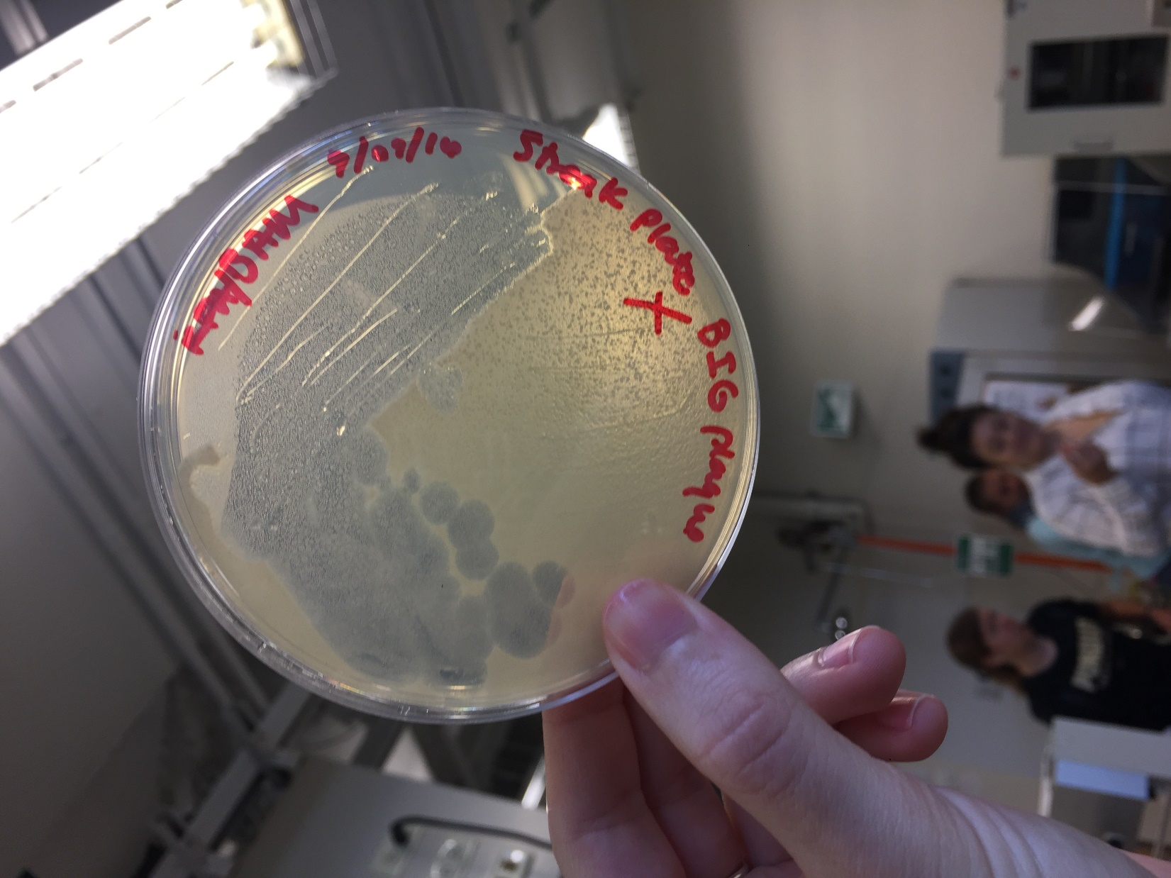

*Figure 43: Streak Plate Big Plaques*

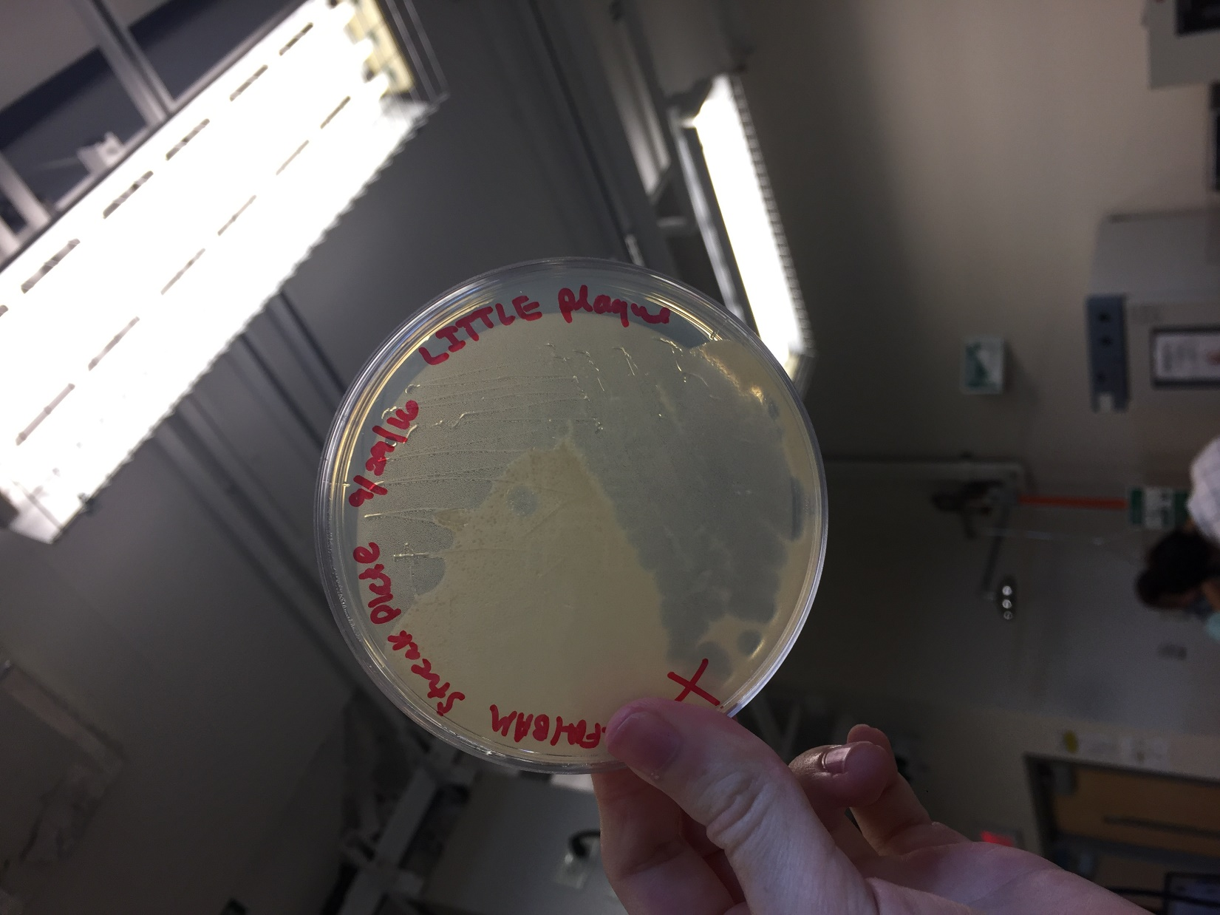

*Figure 44: Streak Plate Little Plaques*

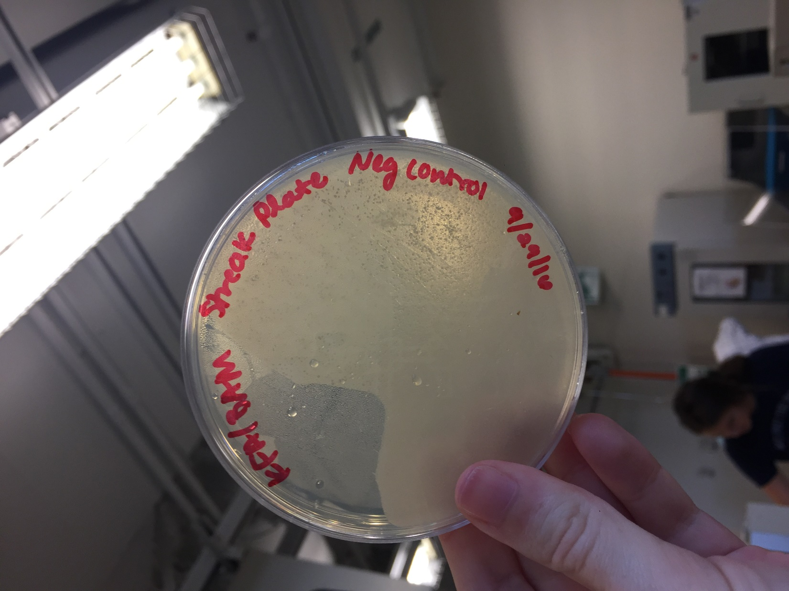

*Figure 45: Streak Plate Negative Control*

**Future Actions**

* On Wednesday, October 5, 2016, my partner will collect the lysate.
* On Thursday, October 6, 2016, we will make serial dilutions of the lysate to determine its titer.